Business Day

Ikea Enters ‘Gig Economy’ by Acquiring TaskRabbit
By TIFFANY HSUSEPT. 28, 2017
Photo
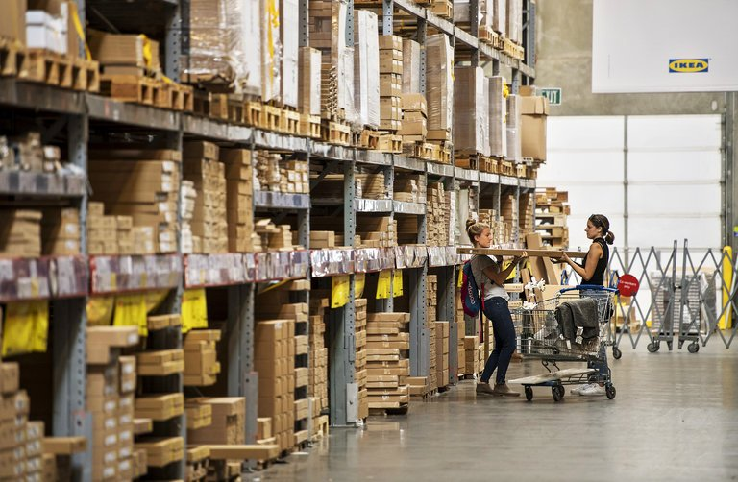
An Ikea store in Emeryville, Calif. The retailer said in a statement that TaskRabbit services could someday be extended globally. Credit David Paul Morris/Bloomberg
Ikea, the Swedish home goods retailer, said on Thursday that it had agreed to acquire TaskRabbit, a company known for, among other things, sending tool-wielding workers to rescue customers befuddled by build-it-yourself furniture kits.
Ikea said that it had signed an agreement to acquire the privately held TaskRabbit but declined to say how much it would pay. TaskRabbit will continue to operate independently once the deal closes, expected in October.
TaskRabbit uses its online marketplace to connect 60,000 freelance workers, or “taskers,” with people looking to hire someone to do chores like furniture assembly, moving and handyman fixes. In their listings, workers specify their hourly rates.
“In a fast-changing retail environment, we continuously strive to develop new and improved products and services to make our customers’ lives a little bit easier,” said Jesper Brodin, chief executive of Ikea. “Entering the on-demand, sharing economy enables us to support that.”
Started in 2008 and based in San Francisco, TaskRabbit operates in 40 cities in the United States and in London. It occupies a busy sector of the so-called gig economy, which includes up to 30 percent of the working-age population, according to a report by McKinsey & Company last year.
Ikea offered few details about how it might integrate TaskRabbit into its operations.
The companies teamed up last year in a pilot program in Britain to offer furniture-assembly services for the retailer’s customers. Customers at Ikea stores in the London area were given the option to build the products themselves, hire Ikea’s in-house assembly service or book a tasker to do the work at their home or office, with TaskRabbit’s fees starting at 20 pounds, or about $27.
Ikea sells its furniture in kits, with illustrations provided as directions. Struggling to assemble a Malm bed or Hemnes dresser surrounded by an array of screws and Allen wrenches is a rite of passage for many denizens of college dormitories and residents of starter apartments. The experience has inspired its share of meltdowns and Reddit threads.
“With Ikea Group ownership, TaskRabbit could realize even greater opportunities; increasing earning potential of Taskers and connecting consumers to a wide range of affordable services,” Stacy Brown-Philpot, chief executive of TaskRabbit, said in a statement.
None of TaskRabbit’s 65 employees will be laid off as a result of the acquisition, and the company plans to hire more workers, said Tod Francis, a managing director at Shasta Ventures, a TaskRabbit investor, in an email.
Ms. Brown-Philpot and the rest of TaskRabbit’s executive team were “committed to staying with the company for the future and well beyond,” he said.
News of the deal, which was signed on Monday, was first reported by Recode.

