Theater

Ticket Pricing Puts ‘Lion King’ Atop Broadway’s Circle of Life
By PATRICK HEALYMARCH 17, 2014
How did “The Lion King” turn around its once-shaky fortunes and become the top-grossing show on Broadway in 2013, an unprecedented feat for long-running musicals, which usually cool after a few hot seasons? Hint: It’s not because it added performances after 16 years.
Since 2011, the show’s producers, Disney Theatrical Productions, have been relying on a previously undisclosed computer algorithm to recommend the highest ticket prices that audiences would be likely to pay for each of the 1,700 seats at every performance in the Minskoff Theater. While other shows also employ this so-called dynamic pricing system to raise seat prices during tourist-heavy holiday weeks, only Disney has reached the level of sophistication achieved in the airline and hotel industries by continually using its algorithm to calibrate prices based on demand and ticket purchasing patterns.
By charging $10 more here, $20 more there, “The Lion King” stunned Broadway at year’s end as the No. 1 earner for the first time since 2003, bumping off the champ, “Wicked.” And Disney even managed to do it by charging half as much for top tickets

King of Broadway
Thanks to new pricing strategies in the last several years, Disney’s “The Lion King” has defied the usual box office declines of long-running Broadway musicals, surging with rising weekly grosses and higher average amounts that audiences pay.

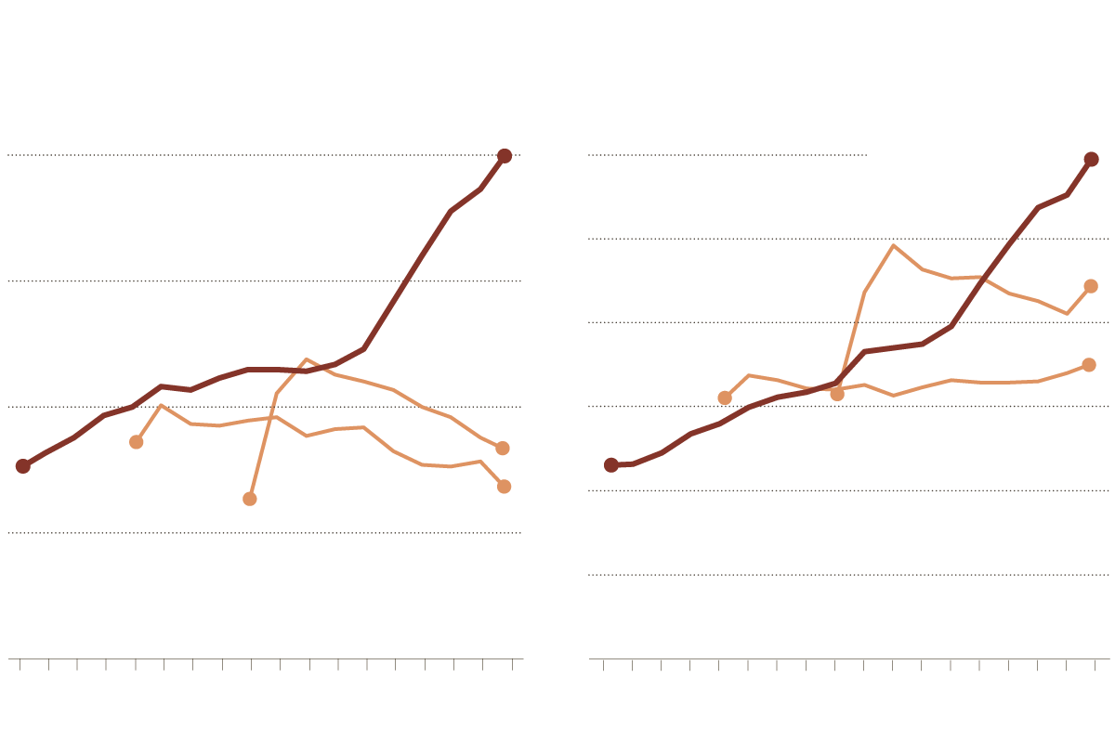
Gross ticket sales
Admission prices
Annual averages of weekly gross sales
Average paid, by year
$150
$2.0 million
THE LION KING
THE LION KING
125
JERSEY BOYS
$1.5
100
JERSEY BOYS
75
$1.0
MAMMA MIA!
$0.5
MAMMA MIA!
25
0
$0.0
’98
’00
’02
’04
’06
’08
’10
’12
’14
’98
’00
’02
’04
’06
’08
’10
’12
’14
Source: The Broadway League
“Everyone would love to get their hands on Disney’s formula,” said Paul Libin, a veteran producer and executive vice president of Jujamcyn Theaters, which owns five of Broadway’s 40 theaters. “All Broadway shows are getting into dynamic pricing as a way to survive, but ‘The Lion King’ has really mastered it.”
Credit the management science experts at Disney’s corporate offices — a data army that no Broadway producer could ever match — for helping develop the winning formula.
Disney executives, who for two years have turned down requests to talk about dynamic pricing for “The Lion King,” recently gave an interview to explain how the show achieved its top ranking. The executives consented in part because dynamic pricing is less of a proprietary issue since more producers are trying it. Even so, not every secret was spilled: Disney rebuffed a request to observe executives analyzing the algorithm’s recommendations and finalizing prices.
Continue reading the main story
The algorithm, a software tool that draws on “Lion King” data for 11.5 million audience members so far, recommends prices for five different types of performances — peak dates like Christmas, off-peak dates like a weeknight in February, and periods in between. Ticket demand from mid-March in recent years, for instance, will influence price recommendations for this week.
To help keep audience demand strong, Disney has made a highly unusual choice among Broadway hits: limiting ticket prices to a maximum of $227 — far less than the top prices for “The Book of Mormon” ($477), “Kinky Boots” ($349) and “Wicked” ($300). Doing so makes “The Lion King” relatively affordable for large groups and families; lessens the chance of buyer’s remorse leading to bad word of mouth; and offers room to raise prices over the long term, according to producers who assess the Broadway industry. Standard ticket prices for “The Lion King” and other Broadway musicals range from around $80 to around $140.
“The Lion King” is widely believed to be selling far more seats for $227 than most Broadway shows sell at their top rates, a situation that bolsters its grosses. (Disney executives declined to comment on this point.) And it’s not just rich tourists who are willing to pay: The top ZIP code for “Lion King” ticket sales is 10025, Disney executives say, a section of Manhattan’s Upper West Side that is by no means its wealthiest.
Continue reading the main story

Visiting the Source | A Chef in the Field: Olive oil
Also in T Magazine »
- True South | New Orleans dining, high and low
- Food Matters | A pilgrimage to a plate

Continue reading the main story
“If you purely listen to what yield management folks would advise, we could charge a little more — certainly for Saturday night or weekends,” said David Schrader, the point person for Disney’s pricing strategies as executive vice president of the theatrical group. “But our theory is, because we’re in this for the long haul, we’ve decided we’re not going to set a new high ticket price for the street.”
Photo
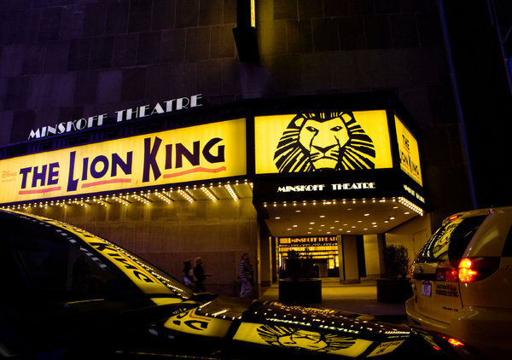
The 2006 move of “The Lion King” to the Minskoff gave it a splashy presence in Times Square. Credit Josh Haner/The New York Times
A New York Times analysis of ticket sales for “The Lion King” shows the success of its pricing strategy, especially compared with those of other long-running shows like “Mamma Mia!” and “Jersey Boys” that now face the traditional multiyear pattern of softening ticket sales, usually a result of competition and diminishing audience interest.
“The Lion King,” based on the animated movie about a young cub’s coming of age in Africa, opened in 1997 to critical acclaim — especially for Julie Taymor’s puppets — and won six Tony Awards, including best musical. Like many Broadway hits, “The Lion King” enjoyed increasing ticket sales early on, often grossing about $1 million a week (or about $1.3 million today). But earnings plateaued as newer musicals like “The Producers” (2001) became hot tickets; Disney even discounted for a time.
In 2006, Disney moved “The Lion King” from the New Amsterdam Theater to the slightly smaller Minskoff to make way for its “Mary Poppins” musical. The move had a marketing upside: the Minskoff’s frontage, which now has a “Lion King” billboard and marquees overlooking bustling Times Square. Yet at the same time, Disney executives became preoccupied with opening new musicals like “The Little Mermaid,” and made a mistake by bundling those shows and “The Lion King” in ads even though their target audiences were different. Ticket sales remained uneven, both before and after the 2008 recession: Weekly grosses fell to $813,466 in March 2009 (or $890,000 today).
By 2010 Disney stopped the traditional strategy of charging one price for whole sections of seats; instead, the producers raised prices for busy weeks by making predictions based on “Lion King” data. A new interactive seating map allowed people to pick locations, and they often opted for better, pricier ones, Disney executives said. The introduction of the algorithm, as well as heavy advertising, caused grosses to surge further. This March “The Lion King” has been grossing $1.5 million a week.
Consumer demand has grown, too — 50,000 more people attended in 2013 than in 2008, for a total of about 700,000.
While “Wicked” (which is 10 years old) has been consistently strong, sometimes using dynamic pricing to sell premium tickets for the most popular spots in its 1,900-seat theater, “Mamma Mia!” has been steadily fading while “Jersey Boys” is counting on a movie adaptation — due out in June — to boost interest in the Broadway musical. Producers of both shows declined to discuss ticket pricing. But since the two musicals rarely sell out, they do not have enough audience demand to test what the market will bear the way Disney can.
The hottest new Broadway musical, “Kinky Boots,” has been using dynamic pricing to charge $349 for 45 to 120 prime orchestra seats a performance (out of 1,400 seats total). Its top price was actually $449 from Thanksgiving through Christmas weeks — a dynamic pricing increase aimed at competing with ticket brokers who charge $1,000 for seats, according to Hal Luftig, a “Kinky Boots” producer.
“I tussled over setting the price at $449, but my investors don’t want to hear I’m having a moral dilemma,” Mr. Luftig said. “So we make educated predictions on price. Disney, on the other hand, has turned this into a science.”
A version of this article appears in print on March 17, 2014, on page A1 of the New York edition with the headline: Ticket Pricing Puts ‘Lion King’ Atop Broadway’s Circle of Life. Order Reprints|Today's Paper|Subscribe

