5 emerging packaging design trends for 2014
By Suley Muratoglu in Packaging Design on August 29, 2014

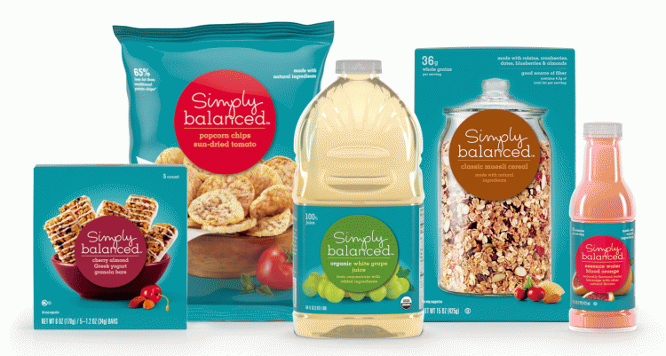
View Gallery
Never in history has product packaging had more influence in buying decisions, which are increasingly being made at the shelf—both real and virtual. Just one in four U.S. consumers now buys based on brand reputation, as noted in a sweeping international survey by Ernst and Young in 2011, which cites digital technology, in particular, as a disruptor of how we shop and buy.
The “chameleon consumer” who is ascending and defying conventional marketing segmentation, notes Ernst and Young, is “hard to read—and even harder to please.” In my experience as Tetra Pak’s vp for marketing and product management, this consumer is open to persuasion from one shopping trip to the next and not only wants, but expects, it all: product innovation, price and quality—all wrapped in a package that fits his or her lifestyle.
For many of these “brand promiscuous” shoppers, package design and marketing are one and the same. From its size, shape and graphical elements, the package is a consumer’s first and last impression of a product, whether life-sized in a brick-and-mortar store or reduced to the size of an icon on a smartphone. That’s why differentiation is so important: Standing out on a crowded shelf or tiny screen with novel shapes, arresting graphics and color will draw the eye. But to close the sale, it’s increasingly important to impart an on-trend message, whether it is serious, aspirational or, increasingly, humorous.
As part of Tetra Pak’s service to its customers, we offer a range of package design services from market insights and trend research to ideation, concept visualization and graphic design consultation and creation. Through that practice, we’ve identified five important, emergent trends in the food and beverage industry that savvy brands are injecting into their packaging to appeal to consumers:

1. Food for Health
For a subset of consumers, healthy eating has been popular for a long time. But studies released this year by the USDA and the Robert Wood Johnson Foundation confirm that there has been a sweeping shift in the U.S., with an extensive part of the population eating healthier foods and, on average, fewer calories. Yet there’s a new way of communicating healthier food and beverage options without stale and off-putting design cues: Packages boast slender silhouettes and sport graphical bathroom scales and measuring tapes. Now “healthy” has a hip demeanor, and design that conveys nutritional benefits without feeling “diet-y” is on trend. Target’s wellness foods brand Simply Balanced is a good design example: The dominant color is a vibrant teal, with appealing photos of ingredients or the products inside, and nutritional information is prominently displayed on the front of the package rather than the back or side. Novel packaging silhouettes are particularly appealing for differentiation in this space.

2. Safe Choice
With ever-more-sophisticated traceability in food processing, retailers now know every step a product took on its path from farm to shelf. And today’s consumers want to be added to the knowledge chain so they know precisely where their food comes from and that it’s safe for their families. This is now possible by adding a secure quick response (SQR) code to a package design that permits shoppers to know with a smartphone app precisely which farm produced their milk. In a similar vein, last year, the Washington, D.C.-based Black Restaurant group launched an SQR-coded menu that allows diners to trace the origins of their dinners, right down to how the fish were caught.
A desire for safe food is also one of several elements driving the powerful local foods movement.. But in addition to safety, consumers also buy local for two reasons: (1) They crave healthier, fresher food and (2) are looking for emotional intangibles, such as feeling connected to the land and to place. Local foodies are attracted to designs that feature farms, pastures, plants and content-looking animals. U.K. manufacturer Butler’s Pantry took a literal approach with design and marketing, prominently featuring farm scene drawings and walking the consumer from farm to table, as noted in retail design firm Artica’s retail design blog.

3. Engaged Experience
If we think of previous generations as loyalty shoppers on autopilot, pushing their carts from one trusted brand to the next, many of today’s consumers are restless wanderers, roaming the shelves and looking for the next new product or flavor to draw them in.
“Every time they go into the store they are looking for something different,” says Kristina DeVerdier, Tetra Pak senior brand manager in packaging design. “There is a company making ice cream flavored with tomatoes now.”
These “wow me” shoppers are persuadable through effectively differentiated designs. That might be a clean, white, simplistic label, as with J Lally’s doodled packages, or one with bright colors or patterns, as with Melgarejo Selección’s olive oils wrapped to look like presents. The packaging becomes a storytelling device, and humor can be an effective tool to help cement the narrative.

4. Green Worriers
This group of shoppers, known as green worriers, is on the leading edge of a growing general awareness that products should be produced and packaged sustainably.
“In general, consumers start feeling guilty if they’re not being responsible,” notes DeVerdier. “But even though they believe this is a very important issue, they rely on the companies to make the decision easy.”
Tetra Pak has a good example of this with its Tetra Evero Aseptic and Tetra Top Aseptic carton bottles, which combine the lighter weight of a paper-based carton (made from sustainably managed forests) with the recloseability and pourability of a plastic bottle. In addition, new bio-plastic caps made from sugar cane represent the most recent move toward creating a carton that is 100-percent sustainably sourced. But it is not enough for brands just to use environmentally friendly packaging; they need to use design to communicate their green credentials. From a graphic-design perspective, brands should be bold and move away from the dowdy “brown paper bag” look that used to signal earth-friendliness.

5. 24/7 Lifestyle
The “constantly connected and always commuting” set is looking for products that are tasty, indulgent and have a home-cooked cachet.
“Many busy people feel bad for eating ready-made food,” DeVerdier says. “They feel like they should be cooking properly for themselves or their family.”
The product inside must back it up, but design can go a long way toward helping customers believe the ready-made food they buy is a good substitute for homemade—or at the very least, that it’s high-quality and great-tasting. Hand-rendered typography is one design device, as with Canadian brand Famoso’s Authentic Campania Tomato Sauce, which was recently featured in lovelypackage.com.
Given these trends, it’s clear that design and marketing are one and the same with today’s shoppers. And thanks to the ever-evolving, ever-growing reach and importance of technology, the cohorts coming up behind them show no sign of reverting to predictable and brand-loyal consumers of yesteryear. In formulating their products, food and beverage manufacturers are adept at tapping into consumer trends. But now, more than ever, it’s critical to communicate those on-trend messages by using smart design to express all the qualities—both timeless and trending—that consumers are looking for in the products they choose to take home.

Suley Muratoglu, vp, marketing and product management, Tetra Pak Inc. U.S & Canada, currently runs the company’s presence in core categories, including dairy, beverage and food. Further industry insights from him can be found at www.doingwhatsgood.us.

