Food & Drink

See-Through Food Packaging Boosts Sales

Clear Packages Draw Shoppers But Are Very Tricky; What's Best Left Unseen
By
Sarah Nassauer

connect

Updated Aug. 13, 2014 2:17 p.m. ET
Consumers love food sold in clear packaging, but it's a struggle for food companies because light degrades food. WSJ's Sarah Nassauer reports on Lunch Break with Sara Murray. Photo: Joshua Scott for The Wall Street Journal
The grocery store is having a moment of clarity.
Yogurt to granola to tortilla chips are showing up in clear packages. The thinking: Shoppers are more inclined to buy when they see what they're getting.
Transparent packaging, though, is surprisingly hard to make. Food often isn't ready for a big reveal after a package has suffered shipping, shelf stocking and other jostling. Companies scrutinize even small packaging changes because they can be expensive. Packaging also drastically affects how long food stays fresh. Light degrades many foods, making clear wrappers especially tricky to use.
Food makers also need to adjust recipes with visibility in mind, making sure fruit pieces are big enough to be seen in yogurt and tortilla chips remain intact.
View Graphics
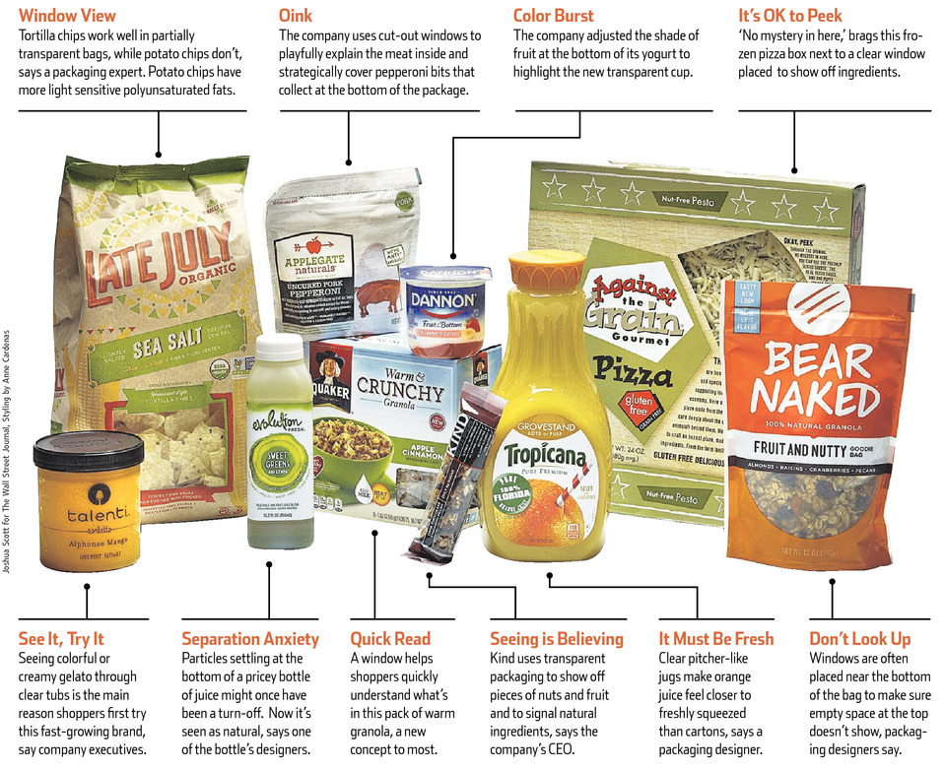
Joshua Scott for The Wall Street Journal, Styling by Anne Cardenas
General Mills Inc. GIS +0.13% General Mills Inc. worked for more than a year to put Larabar Uber fruit-and-nut bars in clear wrappers, says JoAnne Garbe, packaging research and development manager for the company. Her team tested clear films, which are layers of thin plastic fused together to control the flow of oxygen, light and moisture in and out of a package. Each version went into a climate-controlled box to mimic conditions such as grocery store shelves (dark and dry) and a convenience store counter (direct sunlight on a humid day), Ms. Garbe says.
"Oil in nuts is particularly tricky because it oxidizes," when exposed to light, she says.
The effort paid off, says Julia Wing-Larson, marketing manager for Larabar. When the clear wrapper version of the bar hit shelves earlier this year consumers said, in surveys, that the bars looked like they tasted better, felt less artificial and the ingredients seemed fresher, she says. The recipe hadn't changed. General Mills is using more transparent packaging on its other products.
Clear packaging gives products an aura of being natural, something that more shoppers are seeking. Seeing "simple, wholesome ingredients," can be a powerful motivation to buy, says Ms. Wing-Larson. "You eat with your eyes."
More often, the packaging style is also a weapon against the competition. Coca-Cola Co. 's Simply Orange juice has encroached on PepsiCo Inc. 's Tropicana orange juice sales over the past decade in part because it was first to put orange juice in a clear pitcher-shaped bottle. The bottle, marketers say, gave consumers the feeling of drinking something fresh. Tropicana now comes in a clear jug.
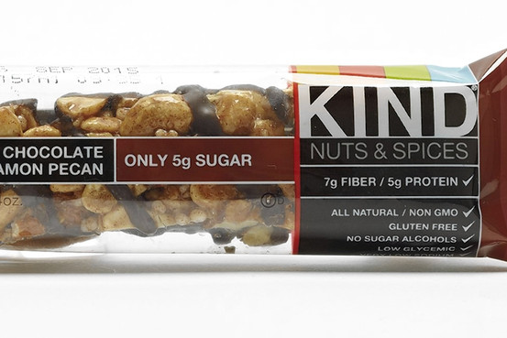
Kind Healthy Snacks, maker of bars and granola, started selling bars in clear wrappers in 2004. F. Martin Ramin/The Wall Street Journal, Styling by Anne Cardenas
Earlier this year, Kind Healthy Snacks, maker of bars and granola in transparent packages, sued competitor Clif Bar & Co. for switching to transparent wrappers on its fruit-and-nut bar.
New York-based Kind started selling bars in clear wrappers in 2004 to "showcase the beautiful artisanal ingredients," says Daniel Lubetzky, founder and chief executive of the company. It took several years to find a manufacturer to make a clear wrapper that kept Kind bars from oxidizing, he says. It is the fastest-growing bar brand in the U.S., according to Euromonitor.
As Clif worked to redesign its Mojo bars, it hoped to use transparent wrappers "to compete head-to-head with Kind," according to court documents that cite internal Clif Bar employee emails. Clif now sells Mojo bars in clear wrappers.
Kind's request for a preliminary injunction was denied. The suit is ongoing, says a Kind spokeswoman. Clif didn't respond to requests for comment.
Food is likely to stay under wraps if it doesn't fill up its package or if it looks messy or factory-made, packaging designers say. Often graphics are strategically placed to cover problem areas. "You don't want to hit people over the head with, 'Look, there are 2 inches of space on the top of this container,' " says Stuart Leslie, president and founder of 4sight Inc., a New York brand design firm that has worked on packages for many large food companies. "Chips guys never show the bottom of the bag," where broken pieces collect, he says.
Foods like oatmeal don't look good in transparent packaging because they get dusty, says Ben Steele, executive creative director at Hornall Anderson, a brand design agency that works on packaging for Quaker and other food companies. When considering clear packages, companies need to ensure food looks good even after it's "put on a truck and shipped to a store and a 16-year-old-boy puts it on the shelf," he says.
Quaker put a small clear window on its new Warm & Crunchy granola to show off the granola, fruit and nut mixes, says Eric Henderson, director of packaging research and development for Quaker, part of PepsiCo. Because the idea of warming granola is new to many shoppers, the window quickly explains what they are buying, he says.
Mr. Henderson's team tested clear plastic films to ensure they would keep the granola fresh up to six months on shelves and were thick enough to withstand granola's pointy edges. Quaker also adjusted the granola itself, coating the pieces with what food scientists call a "barrier" to keep them crunchy when heated.
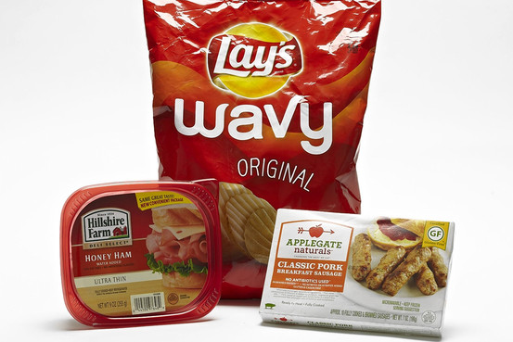
Where Clear Doesn't Work: Potato chips, sandwich meat lids and frozen food. F. Martin Ramin/The Wall Street Journal, Styling by Anne Cardenas
"Edible packaging" is common in packaged food to help it stay fresh longer, no matter the transparency of the packaging, says Claire Sand, an adjunct professor of packaging at Michigan State University who has consulted on packaging for many large food companies. Usually a thin layer of protein or fiber covers one ingredient in a package to keep it moist or stop it from spoiling everything else, producing wonders like the peaceful coexistence of crunchy flakes and chewy raisins in one bag, she says.
That said, as much as shoppers say they want to see what they're buying, sometimes clarity backfires. When Hillshire Farm switched its lunch meat to tubs with clear lids from red lids last year, consumer tests supported the feature. But sales dropped, says Jeff Caswell, vice president and general manager of Hillshire Farm, which is owned by Hillshire Brands Co. Without the fully red lid, shoppers "couldn't find us" on shelves, he says. Hillshire switched back to red lids six months after the change and sales are picking up again, he says.
When Danone SA recently redesigned the packaging of its Dannon yogurt, it not only wanted to improve taste. It also wanted the tubs to be oval for easy scooping and transparent to stand out on increasingly competitive shelves, says Stewart Townsend, vice president of research and development for Danone North America.
Initially, clear plastic proved flimsy in the desired shape, says Mr. Townsend. Over about 18 months, his team tested about six different combinations of materials before finding a solution.
To make the now-visible fruit on the bottom pop, the company adjusted the color with dyes from vegetables and added bigger chunks of fruit, he says. Dannon hasn't used clear packaging since the yogurt came in glass jars in the 1940s and '50s.
Write to Sarah Nassauer at sarah.nassauer@wsj.com

