The Opinion Pages|Op-Ed Columnist

The Self(ie) Generation
MARCH 7, 2014

Charles M. Blow
A fascinating new survey by the Pew Research Center finds that millennials (defined by Pew as Americans ages 18 to 33) are drifting away from traditional institutions — political, religious and cultural.
Before we make a value judgment about these changes, let’s lay them out and understand how fundamentally they will transform the structure of American society and our conception of societal norms.
According to the survey and to Pew’s analysis of it:
■ “Half of millennials now describe themselves as political independents and 29 percent are not affiliated with any religion — numbers that are at or near the highest levels of political and religious disaffiliation recorded for any generation in the last quarter-century.”
■ “Millennials are the first in the modern era to have higher levels of student loan debt, poverty and unemployment, and lower levels of wealth and personal income than their two immediate predecessor generations had at the same age.”
■ “Just 26 percent of millennials are married. When they were the age that millennials are now, 36 percent of Gen Xers, 48 percent of baby boomers and 65 percent of the members of the silent generation were married.”
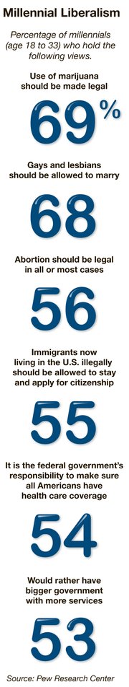
■ “Asked a longstanding social science survey question, ‘Generally speaking, would you say that most people can be trusted or that you can’t be too careful in dealing with people,’ just 19 percent of millennials say most people can be trusted, compared with 31 percent of Gen Xers, 37 percent of silents and 40 percent of boomers.”
■ Millennials “are ‘digital natives’ — the only generation for which” the Internet, mobile technology and social media “are not something they’ve had to adapt to.”
Younger people in general are less likely to say that they are patriotic or religious, but the gap between millennials and Generation Xers is greater than the gap between most other generations.
Millennials also are far more likely than other generations to say they are supporters of gay rights.
Although half of millennials describe themselves as independent, 57 percent say their views on social issues “have become more liberal” over the course of their lives. This is in direct opposition to older generations, who, Pew says, have about half or more of the group saying their social views “have become more conservative.” One might argue that millennials simply haven’t lived long enough to hit the triggers that might engender more conservatism — marriage, families, mortgages — but it could just as well be that this group of young people is fundamentally different.
Part of the political issue is, again, that millennials seem to shun institutions. Only about a third of them said there was a “great deal of difference” between the Republican and Democratic Parties. Still, Republicans have the most to worry about with this group. As the survey puts it: “Even so, this generation stood out in the past two presidential elections as strikingly Democratic. According to national exit polls, the young-old partisan voting gaps in 2008 and 2012 were among the largest in the modern era, with millennials far more supportive than older generations of Barack Obama.”
Continue reading the main story

Why should younger people trust the institutions they feel have failed them?
Ten years ago, 24 percent of millennials identified as Republicans, but that number has steadily dropped and now stands at a paltry 17 percent. By contrast, the percent identifying as Democrats over the period fell only from 30 percent to 27 percent.
Furthermore, millennials were the sole generation in which a majority supported bigger government with more services as opposed to smaller government with fewer services. And although most millennials, like most people in older generations, disapproved of the new health care law, millennials were the only generation in which a majority said it was the government’s responsibility to ensure universal health care coverage.
Part of this divergence results from the fact that millennials are more racially diverse than any other generation, with 43 percent of Americans in this age group nonwhite. When you look just at white millennials, a majority still support smaller government and reject the notion that it’s the government’s job to ensure universal
If there is an opening for Republicans, it is here: Millennials’ views on abortion and gun rights aren’t much dissimilar from that of other generations, and millennials are far less likely to say they are environmentalists.
All in all, we seem to be experiencing a wave of liberal-minded detach-ees, a generation in which institutions are subordinate to the individual and social networks are digitally generated rather than interpersonally accrued.
This is not only the generation of the self; it’s the generation of the selfie.
•
I invite you to join me on Facebook and follow me on Twitter, or e-mail me at chblow@nytimes.com.
Order ReprintsToday's PaperSubscribe

