Marketing to Millennials: 6 Studies & Reports You Need to Read
Tuesday, July 14th, 2015 | 12 min read

Marketers are a little obsessed with millennials. And who can blame them? They’re more digitally connected than any other generation before them, and their spending power is set to surpass $1 trillion by 2020.
Currently between the ages of 18 and 35 (as of 2015), the majority of millennials are hitting major life milestones, such as graduating from college, entering the workforce, settling into long-term relationships, or buying a house. Meanwhile, millennials are redefining what people expect from brands on- and off-line, what adulthood looks like, how adults spend their money (prioritizing experiences vs things), what a typical career looks like, and so on. They’re setting the pace for Gen Z, and they’re even influencing the behavior of their parents, the Baby Boomers.

Already mastered marketing to Millennials?
Get ready for Generation Z
What you need to know
And yet many brands still see the millennial cohort (also known as Generation Y) as elusive – they don’t quite understand how to communicate with them, and they’re skeptical about whether they’re willing to spend like their parents have. As Patrick Spenner points out on Forbes, “Millennials are buying, they’re just buying differently – and, more importantly, they aren’t going to change any time soon.”
Brands need to stop marketing to millennials in the same way they’ve marketed to previous generations. Millennials have flushed out their own set of values and priorities, and they’re looking for brands that embody them.
Here are six resources that will help marketers better understand how to connect authentically with Gen Y.

1. Content Marketing Best Practices Among Millennials
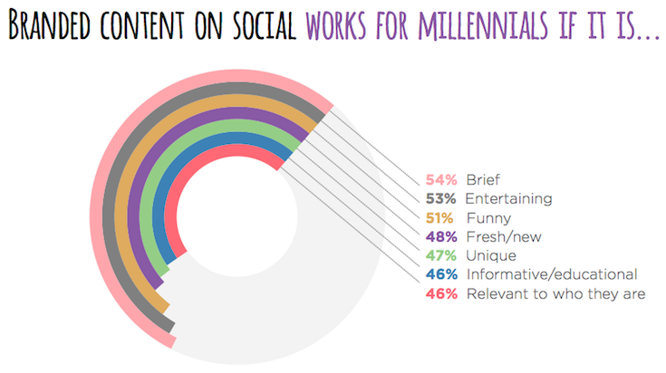
Millennials are the first generation to be truly open to not just receiving ads but also engaging with them and sharing them, yet 45% of millennials don’t find content marketing compelling enough to share it. The opportunity is there, but many marketers have yet to understand how to create content that resonates with Gen Y.
This study, created by Yahoo and Tumblr in partnership with Razorfish and Digitas, guides marketers through content marketing best practices for connecting with millennials. It covers the core values that millennials hold closest to their hearts – like transparency, self-acceptance, and entrepreneurism – and what millennials expect to get out of digital content.
The report looks at five strategic principles for reaching millennials with branded content: Be Native, Not Deceptive; Be An Individual… And Be Ready to Evolve; Deliver on Emotion… And Know That Humor Rules; Reserve Judgment; and Act Like the Locals. It’s packed with stats, colorful mini infographics, and visual aids to back up its points.

Top Takeaway
55% of millennials watch video several times a day on different devices, and 72% want to connect to news across all devices. In other words, millennials consume content across multiple devices pretty much all day long, so marketers need to create content with a “multi-platform” strategy spanning desktop, mobile, and tablet.

2. Understanding Global Millennials: Summary of Findings from Expanded Global Study
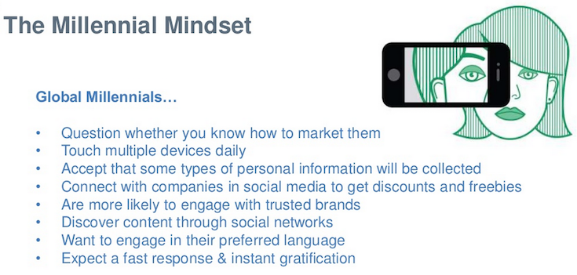
SDL, a customer experience software and services provider, surveyed roughly 1,800 millennials across multiple countries and packaged the results into a 24-page SlideShare that’s been viewed nearly 25,000 times.
The study set out to understand the millennial mindset and consumer behavior. The SDL findings back up the Yahoo/Tumblr report: Millennials want an omnichannel content experience, with 44% expecting their experience to be consistent across all devices. This extends to customer experience in general, as 60% of those surveyed said they expect the same experience across all customer touchpoints when dealing with a company, from phone service to in-store and digital interactions.
Also, trust is big for this generation; millennials are seven times more likely to give personal information to a trusted brand, and 46% share their data if it means they’ll be given a more relevant, personalized experience.

Top Takeaway
Five out of six millennials chose to connect with companies on social media, but they expect their experience to be reciprocal. In other words, they want something in return, such as discounts, free perks, and better customer service.

3. A Labor of Like: Millennials’ 2015 Favorite Brands Ranking Report
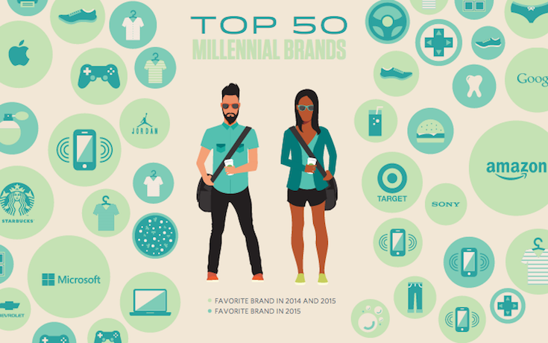
With a slick, modern design to match the millennial cool factor, the 2015 Favorite Brands Ranking Report lists the top 50 brands dubbed millennial favorites. The report is based on two panels conducted by Moosylvania and Great Questions, LLC: one with 500 millennials that identified their favorite brands, and a subsequent panel study with 1,000 millennials examining what traits can transform a high-awareness brand into a trusted friend.
The report says that the brands who consistently rank highest with millennials are those that have pushed beyond traditional advertising methods to build customer relationships representing friendships. In other words, connecting with millennials is all about relatability and trustworthiness.
There’s also an interactive version of the report here.

Top Takeaway
Getting millennials to see your brand as more than just a big company trying to sell them something comes down to three simple directives: make them look good, make them feel good, and entertain them.
Let’s take a closer look at the first one. The report explains that Gen Y seeks brands that help them become something more than their regular selves. Offer a high-quality product or service that helps millennials look cool and they’ll return the favor with their recommendations and purchasing power (something they have a lot of: millennials make $170 billion in purchases per year).

4. Who Are the Millennial Shoppers? And What Do They Really Want?
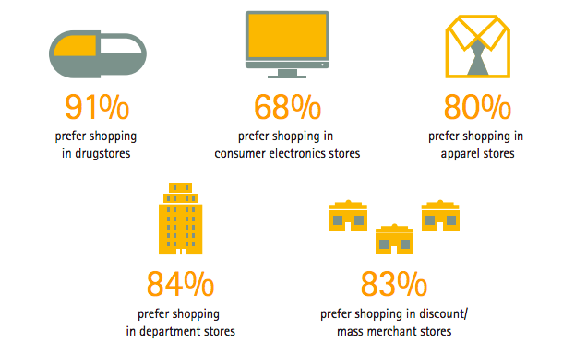
By 2020, Accenture projects that millennial spending in the United States will grow to $1.4 trillion annually and represent 30% of total retail sales. It’s no wonder that brands spend so much time trying to figure out how to connect with this generation, especially when it comes to online and in-store sales.
For this report, Accenture conducted proprietary global market research on the shopping behaviors of 6,000 consumers – of which 1,707 were millennials – across eight countries. Their conclusions focus on what kinds of customer experiences millennials expect from retailers, what millennials expect from brands on social media, and millennial shopping habits.
Accenture challenges three common myths about millennials: that they only care about online shopping, that they are not particularly loyal to brands, and that a like or follow on social media means a millennial is head-over-heels for your brand.
Also, the report reveals that, when it comes to shopping habits, Gen Y has more in common with the Baby Boomers cohort than most marketers think.

Top Takeaway
Research shows that millennials influence the shopping behavior of their parents, who are increasingly mimicking the demands of their children for a seamless customer experience. But what exactly does seamlessness look like? According to Accenture, a seamless customer-facing retail experience will typically include the following four components:
- Customized offerings across channels in the ways millennials want, which boils down to providing better, faster, more memorable service.
- A single “conversation” with customers – one that stays the same across smartphones, desktop, and in-store.
- IT platforms integrated to unify their data sources and boost cross-channel transparency.
- Collaboration with technology, data, analytics, and process partners to provide the service performance millennials want.

5. Mind the Gaps: The 2015 Deloitte Millennial Survey
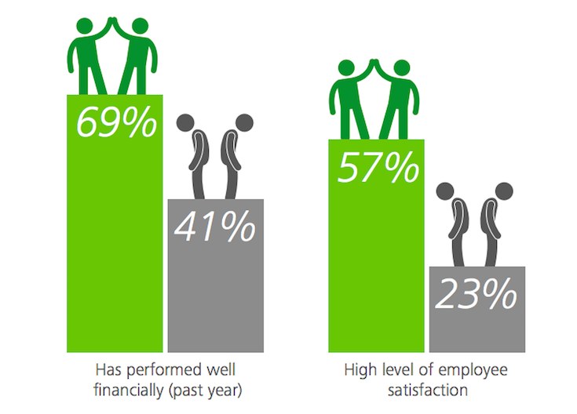
This report by Deloitte examines how millennials view the role of businesses in our society, what they value most in companies, and their visions for effective leadership. Unlike the rest of the resources on this list, this report does not focus on marketing, but it can help brands understand what attracts Gen Y to companies and how they apply their personal values to what they expect from organizations.
Deloitte reveals that millennials are optimistic about corporations: more than 73% believe businesses have a positive impact on wider society. However, Gen Y also believes that companies still have some work to do when it comes to improving the wellbeing of individuals or providing general social benefit.
For millennials, an organization’s treatment of its employees is the most important consideration when deciding if it it’s a leader in its field. They then consider its overall impact on society, financial performance, its record for creating innovative products or services, and whether it has a well-defined and meaningful purpose.

Top Takeaway
When asked to describe what businesses should strive for, millennials highlight job creation, profit generation, and improving society. Millennials also look to businesses to drive innovation and enable progress. They expect an organization to benefit individuals by offering employment, and to have a positive impact on wider society.

6. Millennials Come of Age: ConsumerSpeak Series
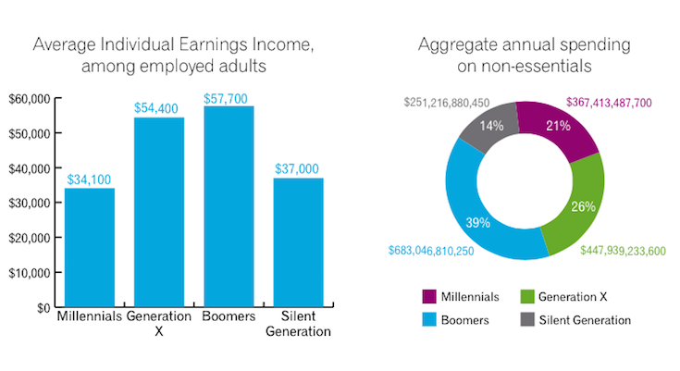
This Experian report is packed with stats on the demographic, psychographic, attitudinal, and behavioral trends of the millennial generation. It’s a great resource to have on hand if you need to pull data to support your millennial-focused marketing campaign or want to brainstorm new ways to effectively target Gen Y.
It covers everything from the typical millennial lifestyle to their values, their attitudes toward money, religious practices, and how they use technology. As the report points out, never before has the United States seen a generation that is so diverse, so informed, and so well connected. Forty-five percent of millennial adults identify as Hispanic and/or non-white, compared to 39% of Generation X (born 1961 – 1979), 27% of Baby Boomers (born 1946 – 1964), and just 17% of the Silent Generation (born 1925 – 1945).
Moreover, during a typical week, millennials spend 67 hours using media, which works out to approximately 9.5 hours a day – more than most Americans sleep.

Top Takeaway
You’ve probably heard countless times that the “selfie generation” lacks ambition, but Experian’s data shows that millennials are actually very career-focused and driven.
Fifty-three percent of employed millennials say that they aim to get to the top of their career, which is a much higher rate than what you’ll find among Generation X and Baby Boomers (38% percent and 25%, respectively). Twenty-eight percent of employed millennials dub themselves workaholics, which is commensurate with both Boomers and Gen Xers.
Entrepreneurialism is also a big part of the generation’s work ethic; forty-six percent of all millennials (and 52% of Hispanic millennials) express a desire to start their own business someday.

Okay, your turn: do you have a favorite study on Millennials that isn’t on the list?

About the Author: Chloe Mason Gray is the Blog Content Manager at Sprinklr. Her writing on marketing, travel, and career development has been published by Mashable, Forbes, KISSmetrics, Entrepreneur, The Daily Muse, the Human Parts Medium collection, and other sites across the web.

