Loyalty and Groups

Revealed: How Steve Jobs Turns Customers into Fanatics
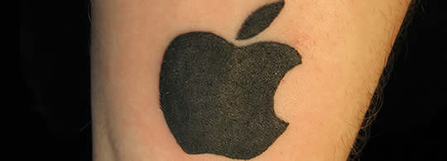
Photo via powerbooktrance
Marketers gaze in envy at brands like Apple. The firm that built some of the first home computers [doh, thanks, alert reader!] has turned their customers into legions of fanatical evangelists. But, without a Steve Jobs at the helm, or with fewer resources than Apple, is building that kind of loyalty possible? I’ve got good news: while having a visionary and charismatic CEO is a big plus, it isn’t necessary to build a fan base, or even a fanatic base. One big secret of Apple’s success lies in an experiment conducted 40 years ago.

The Seminal Experiment
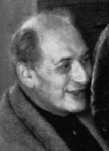Psychologist Henri Tajfel wanted to know how seemingly normal people could commit genocide, and explored how easy or difficult it was to get subjects to identify with one group and discriminate against others. What he found was startling: with the most trivial of distinctions, he could create artificial loyalties to one group, who would then discriminate against those not in that group.
Tajfel tested subjects by having them perform a more or less meaningless task, like choosing between one of two painters or guessing a number of dots shown on a screen. Then, each subject was assigned to a group, ostensibly based on their answer. When the groups were formed and asked to distribute real rewards, they became loyal to their own group and were stingy with the other group. Many variations on this experiment have been performed subsequently, and they have shown that people can develop group loyalty very quickly even in the absence of real differences. Subjects even became emotionally invested in their meaningless groups, cheering for their own group’s rewards and mocking the other group
Tajfel’s experiment (published in Social categorization and intergroup behavior) led to the theory of social identity, which states that people have an inherent tendency to categorize themselves into groups. They then base their identity (in part) on their group affiliations, and build boundaries to keep other groups separate.

Us vs. Them
In neuromarketing terms, our brains are hardwired to WANT to be in one or more groups. Brands that can be positioned to put their customers into a group will find that their efforts will be enhanced by their customers’ own need to belong. In addition, they will likely cultivate a dislike for other brand groups.
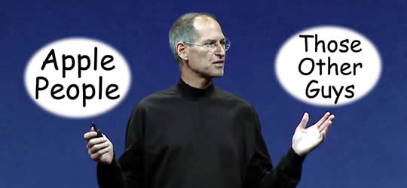
Jumping back to Apple, look how they have leveraged an “Us. vs. Them” approach for decades. Their “1984” commercial certainly drew a sharp distinction between the lone, attractive, athletic young woman and the lines of brainwashed drones.
https://www.youtube.com/watch?feature=player_embedded&v=OYecfV3ubP8

A year later, Apple’s creepy and somewhat depressing “Lemmings” commercial continued to push people into one of two camps; they again portraying PC users as blindfolded businesspeople functioning like suicidal rodents following each other off a cliff.
Fast forwarding to today, look at the wildly popular Mac Guy vs. PC Guy ads. These in particular draw a sharp distinction – do you want to be one of the cool kids, or a dork? https://www.youtube.com/watch?feature=player_embedded&v=WcDpFLSTZWU

Compare People, Not Products
Note the common characteristic of these, and many other, Apple commercials: they focus on the PEOPLE who use each product. These ads convey little or no actual product information, and instead mock PC users while portraying Apple users in a favorable way.
Certainly, other brands have successfully exploited this concept, both directly and indirectly. Could the surprising results that showed Coke-branded cola lit up people’s brains more than Pepsi (whether or not the beverage tasted was Coke or Pepsi) be a result of more people thinking of themselves as “a Coke person” vs. “a Pepsi person?” The famous “Pepsi Generation” campaign was all about Pepsi drinkers as a group, though in the long run Coke has held its leading position.
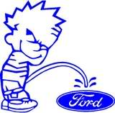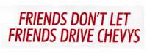Car and truck makers haven’t worked the “us vs. them” angle very much in their ads, but their owner base has certainly picked up on the theme. Truck owners in particular seem to consider themselves part of groups, as shown by the ongoing animosity between Chevy people and Ford people, to say nothing of the clannish owners of HUMMERs.

Our Customers are Different/Better
While the “us vs. them” strategy works better when products are visible to others (cars, apparel, cigarettes, etc.) there is no reason why it couldn’t be employed by nearly any brand people feel at least a little attached to. It’s critical to make your customers feel different, and to interact with them in a way that makes that more credible than a passing ad slogan.

Godin and Tribes
Seth Godin echoes this thought, but states it in his own terms:
Brand management is so 1999.
Brand management was top down, internally focused, political and money based. It involved an MBA managing the brand, the ads, the shelf space, etc… Tribe management is a whole different way of looking at the world…
What people really want is the ability to connect to each other, not to companies. So the permission is used to build a tribe, to build people who want to hear from the company because it helps them connect, it helps them find each other, it gives them a story to tell and something to talk about…
People form tribes with or without us. The challenge is to work for the tribe and make it something even better. [From Seth’s Blog – Tribe Management.]

Do your customers feel like they are part of a group?
Have you been able to make your customers feel different than those of your competition? Does your brand have a tribe? Have you been able to define an “enemy” group that strengthens the cohesiveness of your own? Leave a comment. If I can, I’ll feature a success story or two in a subsequent post.

