Science

Male Sellers on eBay Have an Edge Over Women, Study Finds
By PAM BELLUCKFEB. 19, 2016
Successful sellers on eBay know certain things matter: item description, appealing photos, strong seller ratings and, of course, price.

Now, a study published Friday in the journal Science Advances suggested another factor might make a subtle difference: whether the seller is a man or woman. Using data supplied by the company, researchers analyzed some 630,000 auction transactions on eBay in the United States and reported that, on average, when men and women with equal selling reputations sold the same products, women received lower prices than men.
The difference was far less pronounced for used items: Women sellers received about 97 cents for every dollar men received. But with new items, where the authors say direct comparison is easier, women received about 80 cents on average for every dollar men sellers received.
“The basic point — that people have different expectations of women versus men and so we treat them very differently in the world — it’s fascinating and depressing,” said Linda Babcock, an economics professor at Carnegie Mellon University, who was not involved in the study.
“On eBay, wow,” she added, noting eBay’s fame as a forum where anyone can sell anything. It also does not require that sellers identify their gender. “This would be kind of the best example where you would think that discrimination would be at its smallest. So we can interpret these data as a lower bound of what we can expect in other environments.”
The study did not paint a universally negative picture for women. For some items, like toys and pet products, women received somewhat higher prices than men. And women tended to have better reputations as sellers, although they tended to have less selling experience.
Nor did the study, which controlled for seller reputation, experience, number of photos, use of bold lettering and other elements, indicate that buyers were actively or even consciously discriminating. Male and female buyers appeared to treat women sellers the same, the authors said.

“We actually think that most of it is unconscious,” said Tamar Kricheli-Katz, a professor of law and sociology at Tel Aviv University, who conducted the study with Tali Regev, an economist at IDC Herzliya. “The fact is that most of us have biases. We hold them unconsciously, and it makes it difficult to change.”
Besides analyzing actual eBay transactions, the researchers conducted an experiment to see if people could tell the gender of sellers from user profiles. People guessed correctly in 1,127 of 2,000 cases, wrong in 170 and did not know the rest.
In another experiment, the researchers asked people to place value on a $100 Amazon gift card sold by someone named either Alison or Brad. On average, Alison’s gift card was valued at $83.34, while Brad’s was valued at $87.42.
Claudia Goldin, a Harvard economist and expert on gender wage gaps, said the study was intriguing but needed more analysis. “Just perceiving that somebody’s a woman, what exactly does it mean?” she asked. “It’s got to mean something about the quality of the good or service or something that’s not captured in the data that they have.”
Without that additional information, Dr. Goldin said her hunch is that “the majority of people would be bidding less if they thought that, ‘This really isn’t a 1948 Rolex’ or ‘This really isn’t Jackie Robinson’s signature.’ ”
The researchers said eBay allowed them access to data on transactions, sellers and buyers, including gender. They evaluated transactions from 2009 to 2012, focusing on the 420 most popular items in eBay’s broader categories, and on auctions because no negotiation is involved. Sellers considered to be stores were excluded.
EBay did not provide financing for the study, but set conditions, according to the authors and to editors at Science Advances. The researchers’ contract allowed eBay to approve any study before publication, mostly for potential disclosure of proprietary data and trade secrets; the authors said eBay “ended up approving the study without asking us to drop any of our results.”
Photo
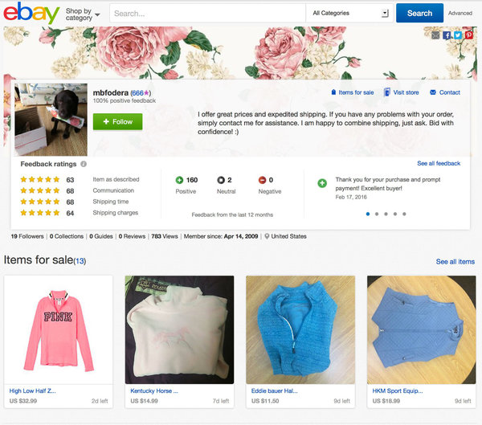
Melanie Fodera’s eBay store page.
EBay declined to discuss the specifics of the study with a reporter. In a statement, the company did not challenge the results. “This study, which was based on data from more than four years ago, was not conducted or commissioned by eBay,” the statement said, adding, “We are passionate about harnessing our platform to empower millions of people by leveling the playing field for them. We do not reveal the gender of our sellers, although they can choose to do that themselves.”
Because the study computed averages, the experience of individual sellers might not match the trend, experts said. Indeed, when The New York Times, in reporting about the study, asked on Facebook if women eBay sellers felt that gender helped or hurt their sales, many people who posted responses said they felt gender was a nonissue on eBay.
Women might be more anxious to finalize the deal and take less on the offer as many are not astute business people.
“Price, shipping, description … that’s what eBay buyers worry about,” wrote Susan Butler Carpenter, a former banker who is now a stay-at-home mother in Pennsylvania and an eBay seller for 16 years. “Anyone who says their gender as a woman has hurt or helped their sales is full of it. Why look for an issue where there is none?”
A few female sellers said they believed some buyers reacted differently because they were women.
Melanie Fodera, 21, a senior at Albion College in Michigan and a seller for about seven years, said when selling a Detroit Lions jersey for “$100 or best offer,” she was offered $50.
“I countered $75, and their message to me was, ‘You don’t know what this is worth because you’re a girl,’ ” said Ms. Fodera, who usually sells women’s clothes and has an eBay page decorated with roses.
Another Facebook commenter, Justina Gilliam, posted: “It all depends on what I’m selling, really. I don’t sell often, but I’ve gotten men who think they can take advantage when I list sports tickets/memorabilia and women who get upset if I can’t answer intricate details about a Lladró that was given to me but I’m getting rid of because I don’t care for it.”
In the 631,516 auctions the authors analyzed, women were about 23 percent of sellers. They received, on average, 0.88 fewer bids for the same items, the authors said. New items, where researchers found the largest gender gap, accounted for 78,350 sales. The biggest advantage for male sellers occurred in categories like new video games (the gap was especially huge for Nintendo Wii).
Continue reading the main story 30Comments
The authors analyzed the text sellers used, finding that women used slightly more positive language, saying “works great” more often than “never used,” for example, Dr. Regev said. But wording differences did not account for the price gap.
Cecilia Ridgeway, a gender issues expert at Stanford, said when reading the study, “I did not think, ‘Oh, eBay needs to fix this.’ I don’t think this is a key thing we’ve got to do for gender equality.”
Still, she said she viewed the study as an indicator of “the importance of gender as a way of making sense of any human being. That doesn’t mean people endorse these beliefs; they just know them.”
Correction: February 19, 2016
An earlier version of this article misstated the name of the journal that published a study about different outcomes for women and men in sales. The journal is Science Advances, not Science.
A version of this article appears in print on February 20, 2016, on page B1 of the New York edition with the headline: Buyers on eBay Bid More for Goods Sold by Men, Study Says . Order Reprints| Today's Paper|Subscribe

