Can You Draw the Starbucks Logo Without Cheating? Probably Not.
By ZACH SCHONBRUNNOV. 12, 2017
16
Photo
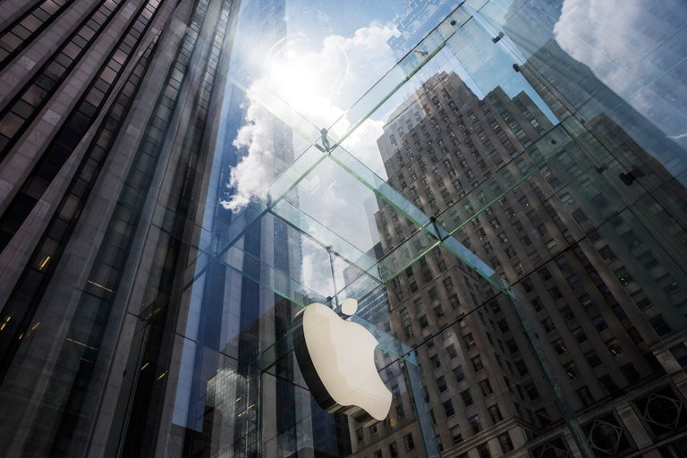
The Apple logo hanging on the Apple Store on Fifth Avenue in New York City. In a recent consumer study, people had a difficult time recreating even some of the corporate world’s simplest and most ubiquitous logos. Credit Andrew Burton/Getty Images
The Apple logo was green. The symbol for Foot Locker was a sneaker. And Starbucks? The famous siren on every frappuccino and chai latte was not exactly the friendliest-looking sea dweller.
When 156 people were recently asked if they could draw some of the world’s most iconic brand logos from memory, some of their recreations were laughably off the mark. But something wasn’t so funny for the companies that have tried to sear their brands into the minds of consumers everywhere: For 10 iconic brands including Wal-Mart, Burger King, and Ikea, the overall percentage of near-perfect drawings was just 16 percent.
That means fewer than one-fifth of the participants could remember the correct positioning of the familiar blue-and-red rectangle of Domino’s, or the three black stripes of Adidas. Even Target — whose emblem involves a simple red bull’s-eye above the brand name — confused people: 41 percent forgot the number of circles.
“People spend so much on marketing to get people to recognize and remember their brand,” said Nelson James, co-founder and chief operating officer of the e-commerce site Signs.com, which led the study. “We just wanted to know — does it work?”

The answer is that being able to recognize a logo and being able to recreate it appear to be vastly different things. Although participants thought they had a good grasp on the designs, expressing confidence that they could redraw them without seeing them, their actual reproductions proved otherwise.
Logos are what companies use to help customers identify the brand, and choices like design, color and font are “critical,” Mr. James said. “Having these logos where you can’t correctly recall details means something.”
In an age of digital saturation, perhaps many of these carefully constructed logos are not as memorable as we think. A study conducted in 2014 by psychologists at the University of California, Los Angeles similarly asked 85 participants if they could draw the familiar Apple logo from memory. More than half the subjects even identified themselves as strictly Apple users. Yet only one could draw the icon perfectly, as scored by a 14-point rubric.
Should Apple be worried? Not necessarily. Dr. Alan Castel, a psychology professor who was one of the authors of the study, said that the inability to accurately recall such daily ephemera as a brand logo really might be a beneficial quirk of our memory system.
“We don’t burden our memory with things we don’t need to know,” Dr. Castel said. He referred to a famous study in 1979 by the psychologists Raymond Nickerson and Marilyn Jager Adams, in which participants were asked to draw the face of a penny. Most struggled.
“It’s rare that you really need to recall something from memory,” Dr. Castel said. “You simply recognize it, you see it on an item or a computer. You like it, you buy it.”
Still, in recent years, brands like Uber, YouTube, and Dropbox have redesigned their logos, trying to make them more simple, more intuitive or more easily recognizable. In 2014, Airbnb announced its new logo, which it calls the Bélo, in a video that noted that the design was easy for customers to draw.
Photo
Airbnb redesigned its logo to be easy to draw, in hopes that customers would use it in their own homes. Credit Matthew Millman for The New York Times
Paul Stafford, co-founder of DesignStudio, the agency that led the rebranding effort, said that Airbnb envisioned people renting out their homes and putting their own spin on the Bélo — on everything from magazines to bathrobes and shampoo bottles, like a hotel.
“We had to create something that was so simple that everybody could draw it and interpret it themselves,” Mr. Stafford said. “They also wanted people to be sharing it. Right down to the people tattooing the mark on their arms.”
Mr. Stafford, however, said that he did not think that being able to draw a logo necessarily indicates how well it resonates.

People often see logos so much that they feel like they know it. But they rarely critique it or study it enough to reproduce fine details — a phenomenon that psychologists like Dr. Castel call “inattentional amnesia.” When something is seen frequently, the information ends up being more easily ignored or forgotten. For instance, Dr. Castel said he would be curious how accurately people could recall the fine details of a stop sign.
“We know it’s red, but the more subtle features — the exact shape of it, whether there’s a white border around it — these are things we often miss, even though we’ve seen it millions of times,” he said.
Perhaps the most surprising result of the Signs.com study was the company that fared best: Ikea. The Swedish furniture maker with the distinctive blue-and-yellow logo plastered across its giant retail stores was redrawn near-perfectly by 30 percent of the participants.
Asa Nordin, who is a senior coordinator of Ikea trademarks at Inter Ikea Systems, said the unique shape, colors, and longevity of the logo — it has been around since 1983 — most likely contributed to its memorability.
“The logo is merely the symbol for what the Ikea brand promises and delivers,” Ms. Nordin said in an email. “The logo shall mirror that ‘promise’ as near as possible, as well as stand out from its surroundings. To be consistent and unique is clearly a strength of a logo.”
The hardest logo to draw was Starbucks, which was redesigned in 2011. It is also arguably the most complex.
“Simplicity is key,” Mr. James said. “That’s not necessarily a new concept. But this definitely corroborates that idea.”
But is any logo overwhelmingly memorable? Mr. James is now curious. Initially, he resisted putting an overly straightforward and ubiquitous symbol in his study, like those of McDonald’s or
“We thought it was too simple,” Mr. James said. “But, I wonder.”

