Advertisers Seek a ‘Second Screen’ Connection With Viewers
By ANNIE LOWREY
MAY 4, 2014
Inside
Photo
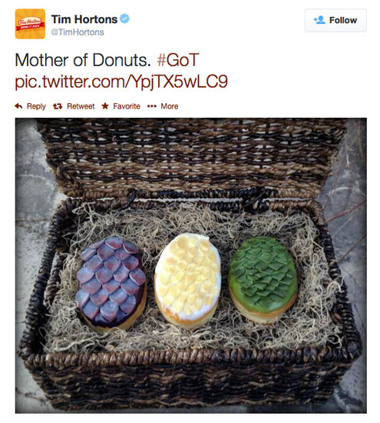
A recent Twitter post by Tim Hortons was tied to “Game of Thrones,” an HBO series.
In recent episodes of “Game of Thrones,” viewers have seen scenes of theft, rape, infanticide, cannibalism, beheading, crucifixion, castration, incest, murder and dismemberment.
While taking all this in, perhaps they would like to think of a favorite snack, beer or cleaning product, too?
The popular HBO series about a bloody civil war in a mythical feudal land reaches a coveted demographic of younger, wealthier viewers. But with no televised advertisements during the show, companies are trying to reach viewers through their smartphones, tablets and laptops with Twitter and Facebook posts.
This is “second-screen advertising,” a rapidly flourishing marketing trend. More than 80 percent of smartphone and tablet owners use their devices while watching television, according to Nielsen. And in trying to reach these multitasking viewers who keep one eye on the show and the other on social media, advertisers are making up the rules as they go.
“Brands are asking themselves, How do I make myself relevant to the first-screen content?” said Joline McGoldrick, research director at Millward Brown Digital. “This is completely nascent behavior, so brands are figuring out what is effective.”
Photo
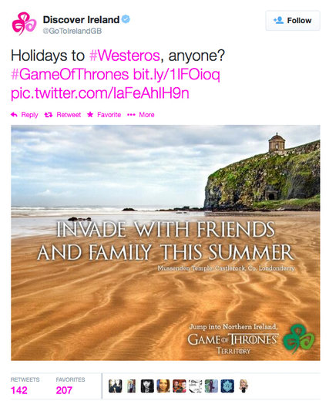
A number of brands have taken to Twitter to capitalize on “Game of Thrones,” on HBO.
When it comes to “Game of Thrones,” the show’s roughly 14 million viewers have proved irresistible to consumer companies — but the program’s deathly serious subject matter has posed a challenge for advertising teams.
Take one Twitter post by Bud Light: “Arriving late to a party might work for Arya, but not for bandwagon fans,” it said, referring both to the series’s johnny-come-lately viewers and to a child who arrives at a castle just after the massacre of her family.
Perhaps by adding levity to the show’s grave content, humor has tended to generate better responses on Twitter and Facebook, the two biggest platforms for second-screen ads. Many posts have punned on popular refrains from the show. References to dragons and death abound.
The American Museum of Natural History put out a promotion for a new dinosaur exhibit with the tagline “The night is dark and full of pterosaurs,” a twist on “The night is dark and full of terrors,” a line from the show. Tim Hortons, the Canadian coffee and doughnut chain, showed a basket of pastries decorated like dragon eggs accompanied by the words “Mother of Donuts.”
Photo
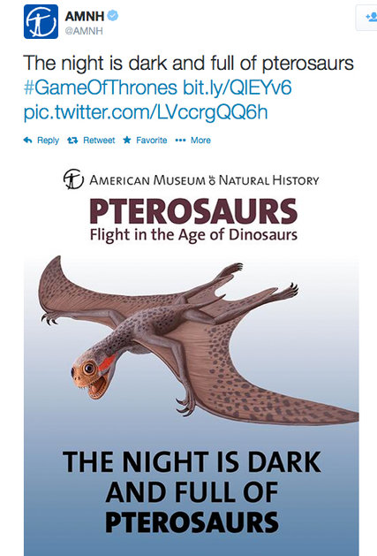
Another example of a brand using Twitter to capture the attention of second-screen viewers.
And Clorox featured a can of disinfecting wipes with the words “A Canister Always Pays Its Debts,” a play on the name Lannister, one of the show’s powerful families. That Twitter message received responses both positive (“NICE hahahaha”) and negative (“that might be the worst one”).
“Our strategy for these sorts of tweets is not only to reach current Clorox customers, but a younger audience, people who might be cleaning for the first time,” said Rita Gorenberg, a public relations and social media manager at Clorox.
She said that figuring out when to put out social-media posts has been a tricky exercise. “There are obviously hundreds of different pop-culture moments that as a brand you can try to jump on,” she said. The company tried to be discerning, she added, creating an advertisement if they found a good hook or a joke. “We try to reach viewers in the moment and be a little disruptive and a little fun.”
But even with less-challenging subject matter, creating second-screen advertisements remains guesswork, given the novelty of the trend and the difficulty of knowing how and when to connect, social-media experts said.
Photo
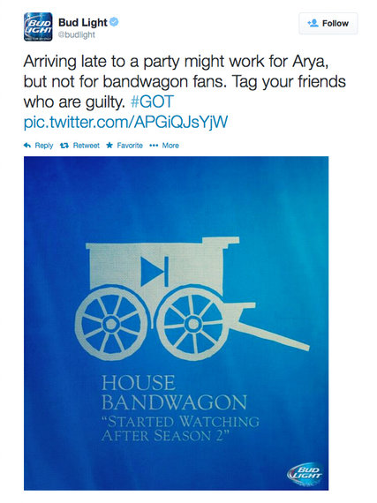
This tweet by Bud Light refers both to the series’s johnny-come-lately viewers and to a child who arrives at a castle just after the massacre of her family.

Some spots have proved hugely successful during live television events like sports and award shows, which often drive the highest levels of social engagement. Oreo, for instance, put up a quick post on Facebook and Twitter that went viral during a power failure at the 2013 Super Bowl.
Ms. Gorenberg said Clorox had received great responses to a bold advertisement that it ran during the finale of “Breaking Bad,” the AMC drama about cancer, death and drug dealing. Clorox drew inspiration from a famous scene in which the main character is shown wearing white briefs. “Clorox Bleach has a long history of being the iconic solution for keeping your tighty-whities white,” she said.
But more often, the ads fail to generate much attention at all, or even seem to be striving and strange to second-screen viewers, who are quick to use social media to attack those that they feel miss the mark. “There’s a mandate to find a way to be relevant during live events,” said Aminatou Sow, a digital consultant. “But it can be really clunky, and often I don’t think it makes a lot of sense.”
Still, viewing trends show that people are increasingly multitasking while watching TV, which has forced marketers to try this new advertising frontier. Roughly one-sixth of viewers engage in “real-time” socializing about what they are watching, according to eMarketer. The younger viewers are, the more likely they are watching with a second screen.
That poses a huge opportunity for marketers, including ones that might not have the budget to place a television spot — or, in the case of an HBO show like “Game of Thrones,” not even have the ability to do so.
Other popular ways of keeping viewers’ attention include offering coupons or discounts for respondents on social media, directing viewers to a website or using new second-screen apps that sync with television programming.
“Your customers are still watching television, and the ones that watch it with a second screen are more engaged than those who don’t,” wrote Michael Guay of Deloitte Digital in an analysis of the market. “But that engagement shifts away from the television during commercials. Syncing your ad with the second screen keeps the viewer engaged.”
A version of this article appears in print on May 5, 2014, on page B1 of the New York edition with the headline: Advertisers Seek a ‘Second Screen’ Connection With Viewers. Order Reprints|Today's Paper|Subscribe

