Think Less, Think Better
Gray Matter
By MOSHE BAR JUNE 17, 2016
Photo
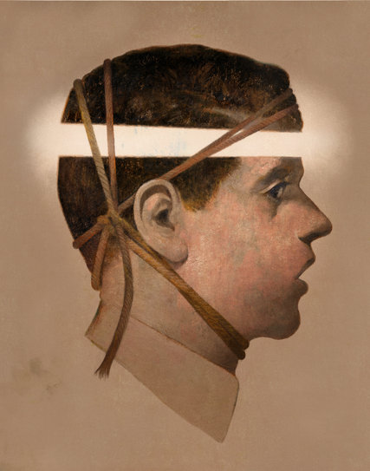
Credit Gérard DuBois
A FRIEND of mine has a bad habit of narrating his experiences as they are taking place. I tease him for being a bystander in his own life. To be fair, we all fail to experience life to the fullest. Typically, our minds are too occupied with thoughts to allow complete immersion even in what is right in front of us.
Sometimes, this is O.K. I am happy not to remember passing a long stretch of my daily commute because my mind has wandered and my morning drive can be done on autopilot. But I do not want to disappear from too much of life. Too often we eat meals without tasting them, look at something beautiful without seeing it. An entire exchange with my daughter (please forgive me) can take place without my being there at all.
Recently, I discovered how much we overlook, not just about the world, but also about the full potential of our inner life, when our mind is cluttered. In a study published in this month’s Psychological Science, the graduate student Shira Baror and I demonstrate that the capacity for original and creative thinking is markedly stymied by stray thoughts, obsessive ruminations and other forms of “mental load.” Many psychologists assume that the mind, left to its own devices, is inclined to follow a well-worn path of familiar associations. But our findings suggest that innovative thinking, not routine ideation, is our default cognitive mode when our minds are clear.
In a series of experiments, we gave participants a free-association task while simultaneously taxing their mental capacity to different degrees. In one experiment, for example, we asked half the participants to keep in mind a string of seven digits, and the other half to remember just two digits. While the participants maintained these strings in working memory, they were given a word (e.g., shoe) and asked to respond as quickly as possible with the first word that came to mind (e.g., sock).
We found that a high mental load consistently diminished the originality and creativity of the response: Participants with seven digits to recall resorted to the most statistically common responses (e.g., white/black), whereas participants with two digits gave less typical, more varied pairings (e.g., white/cloud).
In another experiment, we found that longer response times were correlated with less diverse responses, ruling out the possibility that participants with low mental loads simply took more time to generate an interesting response. Rather, it seems that with a high mental load, you need more time to generate even a conventional thought. These experiments suggest that the mind’s natural tendency is to explore and to favor novelty, but when occupied it looks for the most familiar and inevitably least interesting solution.
In general, there is a tension in our brains between exploration and exploitation. When we are exploratory, we attend to things with a wide scope, curious and desiring to learn. Other times, we rely on, or “exploit,” what we already know, leaning on our expectations, trusting the comfort of a predictable environment. We tend to be more exploratory when traveling to a new country, whereas we are more inclined toward exploitation when returning home after a hard day at work.
Advertisement
Continue reading the main story
Much of our lives are spent somewhere between those extremes. There are functional benefits to both modes: If we were not exploratory, we would never have ventured out of the caves; if we did not exploit the certainty of the familiar, we would have taken too many risks and gone extinct. But there needs to be a healthy balance. Our study suggests that your internal exploration is too often diminished by an overly occupied mind, much as is the case with your experience of your external environment.
In everyday life, you may find yourself “loading” your mind in various ways: memorizing a list of groceries to buy later at the supermarket, rehearsing the name of someone you just met so you don’t forget it, practicing your pitch before entering an important meeting. There are also, of course, the ever-present wanderings of a normal mind. And there are more pathological, or at least more chronic, sources of mental load, such as the ruminative thought patterns characteristic of stress, anxiety and depression. All these loads can consume mental capacity, leading to dull thought and anhedonia — a flattened ability to experience pleasure.
My birthday gift to myself for the last couple of years has been a week of silence at a vipassana meditation retreat. Being silent for a week, and trying to empty your mind of thought, is not for the faint of heart, but I do wish that everyone could try it at least once. During my first retreat, I wondered how a simple tomato could taste so good, why I did not mind physical discomfort as much, how looking at a single flower for 45 minutes was even possible, let alone so gratifying. My thoughts — when I returned to the act of thinking about something rather than nothing — were fresher and more surprising.
It is clear to me that this ancient meditative practice helps free the mind to have richer experiences of the present. Except when you are flying an F-16 aircraft or experiencing extreme fear or having an orgasm, your life leaves too much room for your mind to wander. As a result, only a small fraction of your mental capacity remains engaged in what is before it, and mind-wandering and ruminations become a tax on the quality of your life. Honing an ability to unburden the load on your mind, be it through meditation or some other practice, can bring with it a wonderfully magnified experience of the world — and, as our study suggests, of your own mind.
Moshe Bar, a neuroscientist, is the director of the Multidisciplinary Brain Research Center at Bar-Ilan University and a professor at Harvard Medical School and Massachusetts General Hospital.
Follow The New York Times Opinion section on Facebook and Twitter (@NYTopinion), and sign up for the Opinion Today newsletter.

