Business

McDonald's Faces Sharper Competition in Breakfast Battleground

Rivals From Taco Bell to White Castle Threaten to Cut Into Chain's Morning Business
By
Julie Jargon

connect

Updated April 20, 2014 9:05 p.m. ET
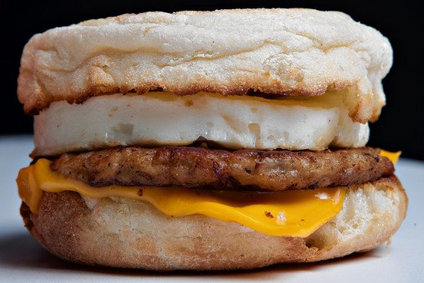
Breakfast is serious business for McDonald's, accounting for about 25% of its U.S. sales. Bloomberg News
Breakfast is the battleground du jour in the restaurant industry, with everyone from Taco Bell to White Castle piling on. For McDonald's Corp. , the pioneer of fast-food breakfast, it is one more area where rivals are gaining traction on its turf.
The burger giant has been struggling to maintain relevance among younger consumers, to fill orders quickly in kitchens that have grown overwhelmed with menu items, and to keep up its standards for service with a smile. While McDonald's is busy trying to correct those issues, competitors are threatening to put a dent in the part of the day McDonald's has long owned: the morning.
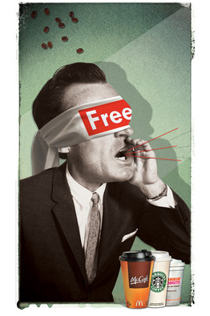
Francisco Caceres
Breakfast is serious business for McDonald's, accounting for about 25% of its U.S. sales. When McDonald's reports first-quarter earnings and March sales on Tuesday, investors likely will be listening for any indication of how the company plans to maintain its breakfast dominance.
Yum Brands Inc.'s Taco Bell last month made its morning meal debut with its Waffle Taco. Also late last month, White Castle Management Co. launched a new Belgian Waffle sandwich. In an apparent answer to the breakfast invasion, McDonald's offered free coffee during breakfast hours from March 31 through April 13, the results of which won't show up until the second quarter.

Related Video
Taco Bell, known for lunch and late, late night dinner, is moving into breakfast. The taco chain has started offering a full breakfast menu at more than 5,000 locations, and in doing so, it is taking aim squarely at its larger rivals. Company president Brian Niccol joins MoneyBeat. Photo: AP.
McDonald's also continues to face heated competition for morning meal dollars from Dunkin' Brands Group Inc., Burger King Worldwide IncMcDonald's Faces Sharper Compe... 04/16/14 Panera Bread Speeds Up Orders ... 04/16/14 Sonic Corp. to Add 1,000 Resta... More quote details and news » and Starbucks Corp. , all of which also report earnings this week. Burger King earlier this month started a breakfast value menu with several items priced at $1. Dunkin' is expanding its reach beyond its Northeastern roots with plans this year to open about 400 stores in California, Colorado, Texas and beyond. Starbucks has been rolling out new La Boulange pastries that it says represent higher quality food to accompany its coffee.
McDonald's reported a drop in U.S. same-store sales for February, its fourth straight month of declines and its seventh consecutive month of missing Wall Street expectations. In January, McDonald's reported flat sales and earnings for the fourth quarter of 2013 as well as its second decline in quarterly same-store sales that year. Analysts expect that its net income narrowed to $1.23 billion in the latest quarter from $1.27 billion a year earlier, while they expect revenue grew slightly, according to estimates from FactSet as of Thursday.
McDonald's stock has recovered in recent weeks from a slump last year, but it is below an all-time high of $103.59 reached last April.
Already, some McDonald's franchisees have expressed skepticism about the coffee promotion and its ability to boost sales. "Giving away free coffee—what a brilliant, creative idea from the geniuses in Oak Brook," one franchisee stated in an anonymous survey conducted recently by Janney Capital Markets analyst Mark Kalinowski.
The franchisees who responded said McDonald's needs to do more than give away products—the company, they say, needs to come up with innovations to juice the business. McDonald's executives are likely to get an earful from them during the company's biannual franchisee convention later this month in Orlando, Fla.
"Oak Brook management is out of ammo," one franchisee said in the survey. "Maybe we'll hear about some new ideas at the convention."
McDonald's declined to comment, citing the quiet period ahead of its financial results.
—The Week Ahead looks at coming corporate events.
Write to Julie Jargon at julie.jargon@wsj.com

