Market-Driven Behavior

‘The Impulse Society,’ by Paul Roberts
By DAVID BROMWICHOCT. 3, 2014
Inside
Photo
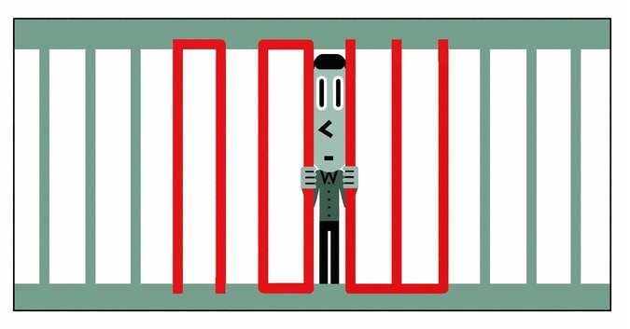
Paul Roberts thinks a society that wants it now is untenable, and he has written a prophecy to tell us why. He begins “The Impulse Society” with a parable: a visit to a rehab center for online gaming addicts. We come to see a player’s outlook, largely a matter of finding suitable opponents, may be changed by the recognition that there is more to life than that. But are we not all players, Roberts asks, when we surf the web and respond yes or no to the “choices” we are spoon-fed?
Though he writes in a neutral tone, Roberts sees that the dangers are great: “With each transaction and upgrade, each choice and click, life moves closer to us, and the world becomes our world.” Our society, he fears, is in the process of enacting “the merger of self and market.” Part of the merger is involuntary. Google, Apple, Facebook and Microsoft have supplied consumer data to the government, but Americans were never asked to approve the National Security Agency’s Prism and XKeyscore systems, which can record the movement of Internet users from site to site and the composition of emails from start to finish (including deletions). That extraordinary evolution of surveillance came from government and market together acting as a shepherd without the consent of the sheep. But if we are watched more than we realize, and more than we would like, it is also true that we have acquired an irrepressible eagerness to watch the lives of others. We pay to be the spectators of our own loss of privacy.
Roberts’s criticism centers on two distinct threats to a society that aims to be responsible, self-governing and interested in the well-being of future generations. The first threat comes from the power of distraction — deployed by the market for its own purposes — which disables us from attending to obligations and even from practicing ordinary prudence. Roberts cites a study that found that people remember the price of things bought with credit cards far less precisely than the price paid in cash. Time we spend looking into an iPad window to choose among 20 deals on jackets is time we might give to looking out of another kind of window and doing something about climate disruption.
Continue reading the main story
A second threat to personal autonomy and social responsibility comes, Roberts says, from our desire for immediate gratification in everything we do, from validating our political opinions to finding the nearest coffee shop. His comments on distraction and on immediacy are pertinent and help to characterize something that has gone badly wrong with American morale in the last 30 years or so. Yet Roberts often treats these separate dangers as if they were the same.
Under the heading of “immediate gratification,” he adduces the iPhone digital assistant Siri, who speaks to her owner in humanoid tones — the first generation of the dematerialized robot whose 10th generation may be the operating system depicted in the movie “Her.” The hero of that movie becomes attached to his system, a cute and upbeat voice with an amusing robot brain, and soon finds he enjoys her company with a cheerful gratitude he could never feel for a human partner. Are his feelings right or wrong? If the robot simulates a human entity and elicits a human response, what basis do we have for criticizing the transaction? The answer depends on ideas about human dignity, reciprocal relationships and the examined life, which the very comforts of technology have made harder for people to dwell on.
Continue reading the main story
Continue reading the main story
A journalist and the author of “The End of Oil” and “The End of Food,” Roberts says his politics have not changed; he was and remains a political liberal. But his diagnosis of the impulse society has led him to “conclusions that are distinctly conservative.” This is less mysterious than he thinks. A conservative may have much in common with a conservationist. “I do not like,” Edmund Burke wrote, “to see any thing destroyed; any void produced in society; any ruin on the face of the land.” If you look on society as a product of human energy that has become a second nature to us, the environment we have to care for includes society itself, as well as the natural world of mountains, lakes and forests.
Much of “The Impulse Society” is a history of the run-up to the financial collapse of 2008. A long-term deterioration of morale was necessary to open the financial market to devices of toxic ingenuity like collateralized debt obligations, which the too-big-to-fail banks sliced and diced and sold to the wise and credulous alike. The corporate raiders of the 1970s and 1980s, Roberts argues, were early adventurers on the same path; corrupt practices in which they engaged, including stock buybacks, did permanent harm to a sense of the common good that once cut across social classes. The company town has almost vanished from American life. More than two million factory jobs were lost between 1979 and 1983, and recovery from the recessions of the 21st century has not been followed by a return of jobs. Why not? Because companies and shareholders found that “the return on technology was better than the return on people.” Manufacturing has fallen from 25 percent of the economy in 1970 to 12 percent today. Between the 1970s and the early 2000s, when stock options and other compensation packages became common, the average chief executive went from being paid 20 times as much as the median employee to being paid 400 times as much.
“The Impulse Society” bears a generally reformist message, supported by uneven rows of miscellaneous facts. Its argument would be clearer if its definitions were sharper. The book’s publicity compares it to “The Culture of Narcissism,” by Christopher Lasch — an absorbing study of the decline of the autonomous personality, widely discussed when it appeared in 1979 — but Roberts says little in depth about personal or social pathology. A fairer book for comparison would be “The Acquisitive Society,” a critique of the ethics of capitalism published in 1920 by the British historian R. H. Tawney. Corporate and dynastic property rights, Tawney believed, were deleterious unless attached to a social function, a kind of productive work that carried a visible benefit for the whole society. The defense of rights without some such function was a defense of privilege, and “the definition of a privilege is a right to which no corresponding function is attached.” There you have three words, closely defined by their interrelations: function, right and privilege. Such definitions may work to build a case for the radical reform of society.
By contrast, the tendency Roberts calls by the name of “impulse” covers a multitude of faults. Sometimes it seems another name for convenience — convenience too quickly and reflexively embraced. But this book also uses “impulse” as a rough synonym for greed, habit, ambition, delusion, shortsightedness and narrow-mindedness. When Roberts speaks of the hot resentment that characterizes some aspects of the Tea Party, and calls the result “impulse politics,” he surely underrates the actual force of ideology. “The Impulse Society” sounds a memorable alarm with its record of disturbing facts and trends, but it leaves us uncertain what path we should follow to escape our predicament, and what end we should have in view.

THE IMPULSE SOCIETY

America in the Age of Instant Gratification
By Paul Roberts
308 pp. Bloomsbury. $28.

