MKTG 310 A
6/29/2014
Drop Box 1

Introducing the following secondary information collected from several sites that provides some information about the US population. Marketers can look at these numbers and help form an idea of how to segment their consumers and plan for marketing strategy that will improve business to compete strongly in the market. In this report will focus on African American, Asian, and Hispanic population.

AFRICAN AMERICAN
Total numbers in the U.S | 41 Million
 | http://www.cdc.gov/minorityhealth/populations/remp/black.html
Percent of the total U. S. population | 13.10%
 | http://www.cdc.gov/minorityhealth/populations/remp/black.html
Rate of growth | Increased by 12% between 2000 and 2010
 | https://www.esri.com/data/esri_data/~/media/Files/Pdfs/library/brochures/pdfs/minority-population-growth.pdf
Average household size | 2.63
 | http://reachingblackconsumers.com/2012/06/black-households-and-the-opportunities-they-present/
Average age | 30
 | http://www.allied-media.com/Publications/african_american_publications_.htm
% with college degrees | 18.70%
 | http://factfinder2.census.gov/faces/tableservices/jsf/pages/productview.xhtml?src=bkmk
Average or median income levels | $33,321
 | http://www.census.gov/newsroom/releases/archives/facts_for_features_special_editions/cb14-ff03.html
Geographic location(s) – metro, states, etc. | District of Columbia (51.6%) and Mississippi (38%). Location with the largest total number of black residents (in 2012) was New York (3.7 million).
 | http://www.cdc.gov/minorityhealth/populations/remp/black.html

Brands that have higher than average purchase for African American
http://nnpa.org/wp-content/uploads/2013/06/African-American-Consumer-Report-2013.pdf
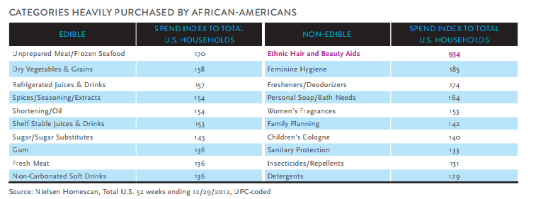
Identify specific products which have above average usage for African American
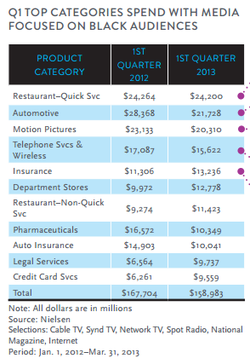

Best media to use to target African American
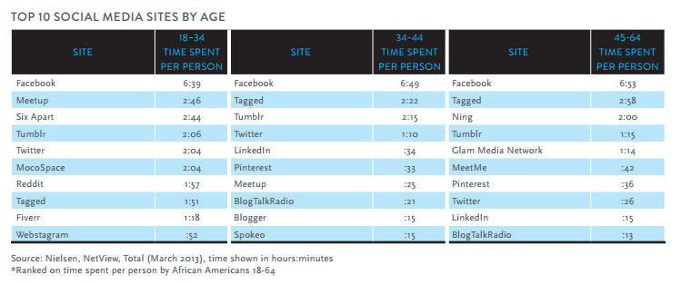

ASIAN AMERICAN

Total numbers in the U.S. | 14.7 Million
 | http://www.cdc.gov/minorityhealth/populations/remp/black.html
Percent of the total U. S. population | 5.00%
 | http://www.cdc.gov/minorityhealth/populations/remp/black.html
Rate of growth | Increased 45% between 2000 and 2010
 | http://www.census.gov/prod/cen2010/briefs/c2010br-11.pdf
Average household size | 3.52
 | http://www.census.gov/prod/cen2010/briefs/c2010br-11.pdf
Average age | 38
 | http://www.census.gov/prod/cen2010/briefs/c2010br-11.pdf
% with college degrees | 44%
 | http://www.census.gov/prod/cen2010/briefs/c2010br-11.pdf
Average or median income levels | $63000  http://www.census.gov/prod/cen2010/briefs/c2010br-11.pdf
Geographic location(s) –metro, states, etc. | New York, California, Illinois and Texas  http://www.census.gov/prod/cen2010/briefs/c2010br-11.pdf

Brands that have higher than average purchase for Asian American

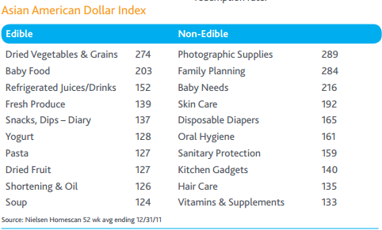
Identify specific products which have above average usage for Asian Americans
- Follow Latest Technology
- Prime Customers of Home Electronics Retailers
- PCs Heavily Used in their Homes
- Ecommerce More Popular among Asian Americans
- Attuned to Online Marketing and Advertising
- Cell Phones are more Common
http://www.packagedfacts.com/sitemap/product.asp?productid=1119537
Best media to use to target Asian Americans
Asians visit these sites 36% more often, spend 72% more time and visit 84% more pages than the total population.
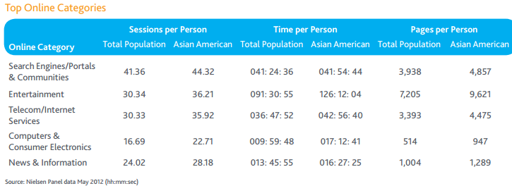

HISPANIC AMERICANS

Total numbers in the U.S. | 53 Million
 | http://factfinder2.census.gov/faces/tableservices/jsf/pages/productview.xhtml?src=bkmk
Percent of the total U. S. population | 17%
 | http://factfinder2.census.gov/faces/tableservices/jsf/pages/productview.xhtml?src=bkmk
Rate of growth | Increased 42% from last census in 2000
 | http://factfinder2.census.gov/faces/tableservices/jsf/pages/productview.xhtml?src=bkmk
Average household size | 3.87
 | http://www.pop.org/content/hispanic-family-size-in-usa-shrinking-93
Average age | 27
 | http://www.pewresearch.org/daily-number/median-age-for-hispanics-is-lower-than-median-age-for-total-u-s-population/
% with college degrees | 13%
 | http://factfinder2.census.gov/faces/tableservices/jsf/pages/productview.xhtml?fpt=table
Average or median income levels | $38000  http://www.census.gov/prod/cen2010/briefs/c2010br-11.pdf

Geographic location(s) –metro, states, etc.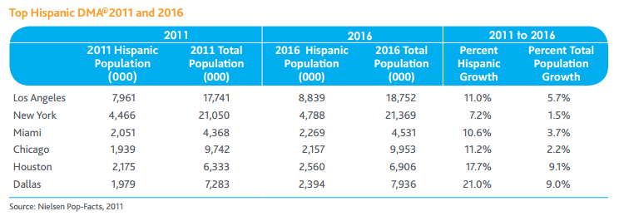
Brands that have higher than average purchase for Hispanic American
The report also ranked the top 10 Hispanic American household goods purchase categories by dollar volume index:
1. Dried vegetables and grains (190)
2. Ice (188)
3. Baby food (175)
4. Baby needs (172)
5. Disposable diapers (164)
6. Hair care (144)
7. Family planning (143)
8. Women's fragrances (140)
9. Grooming aids (136)
10. Shelf-stable juices, drinks (133)
http://www.adweek.com/news/advertising-branding/hispanic-consumers-outspend-dried-veggies-grains-104942

Best media to use to target Hispanic Americans
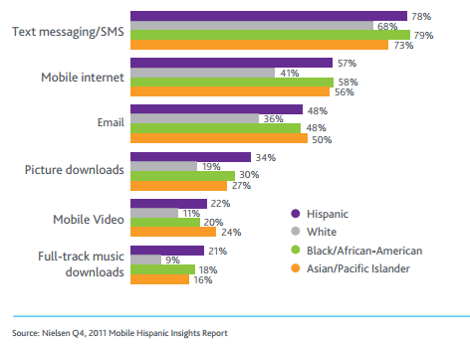
http://es.nielsen.com/site/documents/State_of_Hispanic_Consumer_Report_4-16-FINAL.pdf

BUSINESS POTENTIAL

African American
African American population continually growing compared them to other groups. "Black buying power continues to increase, rising from its current $1 trillion level to a forecasted $1.3 trillion by 2017.2” (Neilson study). According to Neilson, a leading global provider of insights and analytics, study shows the increase in shopping trends among this segment especially in household items, health and beauty, travel and electronics. They are more loyal segment to brand names compared them to other groups.
African Americans are the second largest minority in the country with an a strong buying power that can be exploited and explored unfortunately because of the racial legal issues, marketers have focused on the big next thing, in this case the focus is on the Hispanic and Asian Americans, and left the African American group behind. According to Nielsen, “total spending in Spanish-language media in the first three quarters of 2008 was $4.3 billion, up 2.7% from the year before. Total spending on African-American media in that time period was $1.8 billion, down 5.3% from the same period in 2007.”
As Marketer, I will focus more on women African Americans. Their power buying might not be as strong as the other groups but connecting with this segment will not be as complicated as if targeting Asians or Hispanics.

Asian American
Asian Americans are also a fast growing segment with higher purchasing power; they are well educated and technologically savvy. Asian American population is considered a powerful economic force that can drive business growth. The fact that many of the Asian Americans are immigrant from countries that perceives American product as indicator of high quality therefore higher status. They are likely to spend more on brand names to keep the same status they perceived to have before coming to USA.

“The Asian-American household median income is 28 percent higher than the total U.S. median in 2012” (Neilson Study) alongside with their higher income and their education, this populations have a lot to offer the market. Marketers can’t afford to not pay attention to this group. Although the challenge to reach this group is more cultural than anything else, the fact that this group live in communities it give the marketers an advantage to learn about their communities and offer the product mix that are more demanded.

Hispanic American
The Hispanic population is the largest minority segment in US and is growing faster than other minorities. Carrying the product or service alone to target Hispanic population isn’t enough. Marketers are to find a way to develop programs that are culturally relevant to this group. Family is a key to reach out to Hispanics. It is important to customize materials as well as product mix to suite their demand.
As a marketer, building a strategic partnership with media channels that serves Spanish speaking will allow easy access to connect with this group. According to Roslow research study, “Spanish language advertising is 45% more effective than English advertising” in reaching this consumer segment” (Roslow)
Strong family and community ties are very important with this group. The feeling of inclusion and belonging is a key element to achieve a long term loyal relationship with Hispanics. As marketer, using the cultural events like Cinco de Mayo and other Hispanic holidays to build and connect with this consumer segment. Recruiting staff that can communicate and understand their needs and concerns will further improve the chance of reaching to the right consumers and therefore build a strong relationship.
Hispanic youth tend to hold to their family values and respect their traditions. This segment is growing and is going unnoticed. Although these youngsters speak English, their loyalty to their home brand names and traditions could be imaged locally and developed here at home.

BIBLIOGRAPHY

Centers for Disease Control and Prevention. Centers for Disease Control and Prevention, 10 Feb. 2014. Web. 29 June 2014.

Esri. Minority Population Growth--The New Boom (n.d.): n. pag. Https://www.esri.com/data/esri_data/~/media/Files/Pdfs/library/brochures/pdfs/minority-population-growth.pdf. Web.

"African American Publications- Ethnic Media - Community Outreach." African American Publications- Ethnic Media - Community Outreach. N.p., n.d. Web. 29 June 2014.

"American FactFinder - Results ." American FactFinder - Results . N.p., n.d. Web. 26 June 2014.

"United States Census Bureau." Facts for Features: Black (African-American) History Month: February 2014. N.p., n.d. Web. 29 June 2014.

Black, Voice Of The, and Community. Resilient, Receptive and Relevant (n.d.): n. pag. Http://nnpa.org/wp-content/uploads/2013/06/African-American-Consumer-Report-2013.pdf. Web.

"Marketers Shouldn't Bypass African-American Consumers | News - Advertising Age." Advertising Age News RSS. N.p., n.d. Web. 29 June 2014.

Bureau, U.s. Census. The Asian Population: 2010 (n.d.): n. pag. Http://www.census.gov/prod/cen2010/briefs/c2010br-11.pdf. Web.

"Marketing to Asian Americans--Direct Marketing, Mail Order, E-commerce News." Marketing to Asian Americans--Direct Marketing, Mail Order, E-commerce News. N.p., n.d. Web. 29 June 2014

Http://www.allied-media.com/hispanic%20market/hispanic_american_market.html. N.p., n.d. Web.
Http://www.pop.org/content/hispanic-family-size-in-usa-shrinking-93. N.p., n.d. Web.

Report. The Hispanic Market Imperative (n.d.): n. pag. Http://es.nielsen.com/site/documents/State_of_Hispanic_Consumer_Report_4-16-FINAL.pdf. Web.

Http://www.adweek.com/news/advertising-branding/hispanic-consumers-outspend-dried-veggies-grains-104942. N.p., n.d. Web.

Http://www.adweek.com/news/advertising-branding/hispanic-consumers-outspend-dried-veggies-grains-104942. N.p., n.d. Web.

