U.S. News

Baby Bust Threatens Growth
‘Economists Say the Recession Ended in 2009, but Nobody Told American Women’
By
Neil Shah
Dec. 4, 2014 12:01 a.m. ET
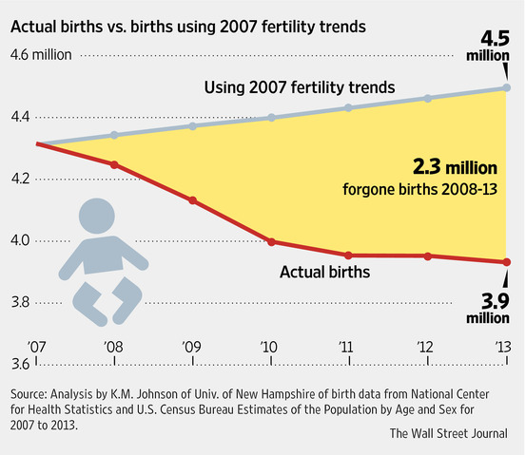
LOST YOUTHS: One demographer predicts there would have been 2.3 million more births if the recession hadn’t gotten in the way.
The U.S. economy, already struggling with stagnant wages and lackluster spending, faces another obstacle to growth: missing babies.
The nation’s fertility rate edged down last year to a record low, the latest notch in a long decline made worse by the recent recession. For every 1,000 women of childbearing age, there were just 62.5 births, down from 63 births in 2012, according to the Centers for Disease Control and Prevention.
Lower fertility means less growth in the U.S. population, barring an increase in immigration, which is only slowly picking up. That means fewer workers to propel the economy and a smaller tax base to finance benefits for the elderly. The trend also promises to weigh on consumer spending, which fuels two-thirds of economic activity; if fewer women have children, there’s less buying of diapers, school supplies and homes to accommodate growing families.
Cuyahoga County in Northeast Ohio, home to Cleveland, is seeing the impact of the trend firsthand. The number of births in the county was around 13,800 last year, down from nearly 19,000 in 2000. Edward Roshong, executive director of education for the Parma City School District, says the Cleveland suburb has roughly half the students it did in the 1970s—resulting in the closing of several elementary schools over the past few years.
While an aging population and young people moving away is part of the problem in places like Cuyahoga County, so is the fact that the young couples who do stay are delaying child-rearing, said Tracy Healy, president of FutureThink, a firm that helps local school districts in their planning.
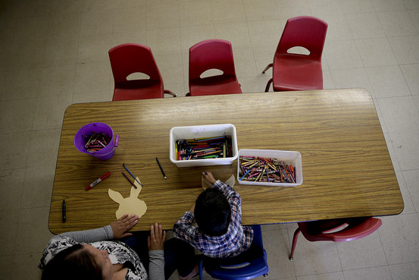
Declining birthrates have been weighing on enrollment in schools, like this preschool in Garden Grove, Calif., shown earlier this year. Associated Press
“People are having fewer kids and waiting longer,” she said. “There is such excess capacity in so many of the school buildings.”
Many demographers have forecast a recovery in births as the economy improves and more young people start having families. But while America’s “baby bust” at least seems to be leveling off, the now-five-year-old economic recovery has yet to translate into an upturn in births.
“Economists say the recession ended in 2009, but nobody told American women,” said Kenneth Johnson, a demographer at the University of New Hampshire.
Fertility typically drops in developed countries during recessions, mostly due to high unemployment, but the impact tends to be minor and last two to five years, according to Mark Mather of the Population Reference Bureau, a nonprofit demographic-research group.
Yet the 2007-09 recession exacerbated a downtrend in fertility rates that itself was driven by delayed marriages, increased college attendance and female labor-force participation, access to contraception and higher costs for raising a family.
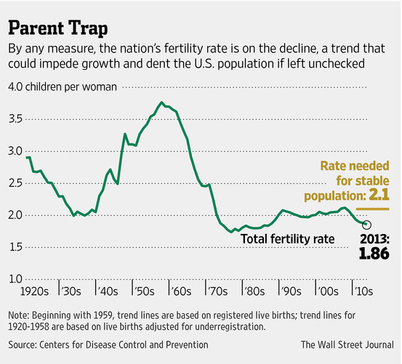
Last year, the number of births slipped to 3.93 million from 3.95 million. That is striking given that since 2007 the number of women in their prime childbearing years—20 to 39 years old—has risen by 1.6 million. Mr. Johnson estimates 2.3 million more babies would have been born in aggregate if America’s prerecession trends had continued.
Meanwhile, the nation’s “total fertility rate”—a statistical measure of how many children each woman is likely to have over her lifetime—also has dropped, to 1.86 from 1.88. That is below the 2.1 children needed to keep the population stable.
It is possible an uptick in births could be around the corner. While the nation’s overall fertility rate fell 1% last year, the rate rose slightly for non-Hispanic white women. Women in their 30s, who tend to be more financially stable, also saw their fertility rates rise. Any recovery in births could be led by older and better-educated women.
And as more millennials—young adults between 18 and 34 years old—begin having children, the U.S. could even see something like a “baby boomlet” given the large size of that contingent, demographers say.
A big question is what Hispanic women will do. Hispanic women were disproportionately affected by the recession, and could be the group that makes up for delayed births. But fertility among Hispanic women has been falling faster than for other groups for years, and this trend could outweigh any postrecession-related uptick.
There is another possibility: that what happened during the Great Depression happens now.
American women who turned 21 in 1930 had “the least births of any cohort in history,” said Mr. Johnson, though a baby boom started after World War II as the economy improved, partly due to earlier postponements.
Dawn and Damon Fryauff are one couple who would like to have children, if only their finances would cooperate.
The couple, who live in Willoughby, Ohio—northeast of Cuyahoga County—live off Mr. Fryauff’s income working part time in a local grocery store. Ms. Fryauff, 34, has a health condition that prevents her from working, though she gets disability checks. They regularly don’t have enough each month to pay the bills.
“We can’t afford it,” she said, talking about their desire to have a child. “But it’s not like I can wait until I’m 45 and stable.”
Write to Neil Shah at neil.shah@wsj.com

