World Cup

In the End, There Was No Saving U.S.

Americans Fall to Belgium as Late Rally Falls Short
By
Matthew Futterman

connect

Updated July 1, 2014 9:03 p.m. ET
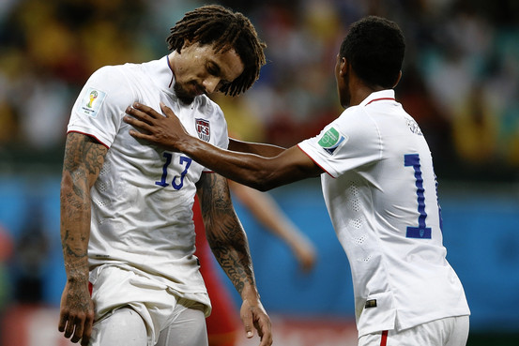
Jermaine Jones is consoled by teammate Julian Green after the U.S. run at soccer's World Cup ended Tuesday in Brazil. Adrian Dennis/Agence France-Presse/Getty Images
Salvador, Brazil
It was the best goalkeeping performance in memory. It was backed by an all-out, team-wide, never-give-up effort. And it still wasn't enough.
In losing 2-1 in extra time to Belgium in the round of 16 on Tuesday, a defeat that ended the Americans' World Cup run, the U.S. men's national soccer team displayed just the sort of spirit that captivated the country over the past two weeks.
"It is something that is ingrained in the American spirit that we will never give up, we will never stop fighting," said U.S. defender Omar Gonzalez. "I really hope that the fans across the world saw that today—that we never stop fighting."
But the match also was a reminder of how far American soccer has yet to go and how hard it is to reach the top level of the international game.
In New York's Bryant Park, fans of the U.S. men's national soccer team reacted to the Americans' loss to Belgium in the World Cup round of 16.
The Belgians, dominant throughout, finally broke through three minutes into extra time. Kevin De Bruyne picked up a loose ball 10 yards out, turned and hammered home a goal to break a scoreless tie. The score spelled a bitter ending to a magical night for goalkeeper Tim Howard, who faced 38 shots, 27 of them on target, and sent away all but two. (Read more about Belgium's team.)
Twelve minutes later, Romelu Lukaku one-timed a perfectly slotted ball from De Bruyne to beat Howard for what looked like an exclamation point but ended up being the game-winner.
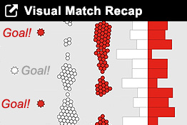
A minute-by-minute statistical breakdown of how the match of the day played out: Inside the Box.
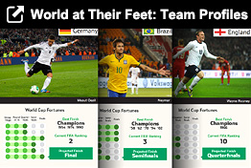
Key players to watch, from Lionel Messi to Xavi to Cristiano Ronaldo: Team Profiles
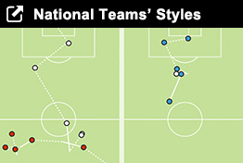
Six goals and what they show about team strategy: National Teams' Styles
The U.S., given little chance of getting this far, didn't go quietly. Julian Green, the 19-year-old German-American pegged to be the nation's best hope, volleyed in a chip over the middle to pull the U.S. within a goal with 12 minutes to play, creating some frayed nerves in Brussels and Bruges.
With tens of thousands of U.S. faithful chanting "USA, USA," the Americans looked like they would get even closer, with Jermaine Jones nearly tying it on a header from 4 yards out a minute later and Clint Dempsey hammering a ball into goalkeeper Thibault Courtois's stomach from point-blank range. It turned out that was as close as the Americans would come.
"It's a bummer for us, ending on the losing side after a game of 120 minutes," said U.S. coach Jurgen Klinsmannn, who said his players "gave everything they had. They made their country proud."
The U.S. was vastly outplayed in this game. But for more than 120 minutes, the Americans hung in. They did so almost entirely because of their goalkeeper, who repeatedly kept the game scoreless with his fingertips, his shin, the studs of his cleats or any other body part he could manage to get on the ball.
"It hurts, losing always hurts," Howard said of the defeat. "But I think when we played so well it stings that much more."
On the strength of Howard's acrobatics in net and a gutsy effort from DeAndre Yedlin—a 20-year-old substitute who only the most devout of American soccer wonks had heard of a month ago—the U.S. managed to fall just short of reaching the quarterfinals.

Photos: Tim Howard in Action Against Belgium
View Slideshow
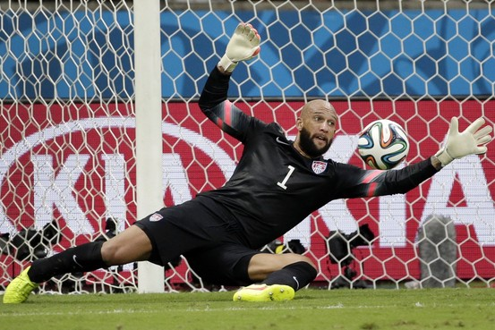
AP
"We went back and forth with them for 90 minutes," said defender Matt Besler. "We were a chance away. They were a chance away."
But in what became a disturbing pattern as the World Cup wore on, the U.S. let their opponents control the run of play from the opening whistle and for much of the first half. Belgium created 82 dangerous attacks to 54 for the U.S. and 38 attempts on the goal to 14 for the U.S.
The American hopes appeared to collapse a half-hour into the game, when Fabian Johnson pulled up lame with a strained hamstring as he stretched for a ball. Johnson was replaced by Yedlin, the ultimate bubble choice for the roster. But the speedy Yedlin almost immediately started wreaking havoc with the banged-up and heavy-footed Belgian defense.
For the U.S., the future appears bright, if the team can find some players who can keep possession of the ball when the games get hard, as they inevitably will in a World Cup round of 16.
Klinsmann is signed on for another four years, though he was the slightest bit noncommittal when asked if he expected to be coaching the team in Russia in 2018. "I think so," he said.
Enlarge Image Close
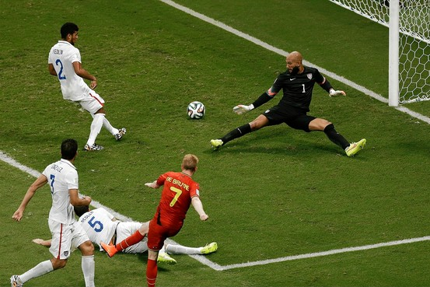
U.S. goalkeeper Tim Howard watches Belgium's Kevin De Bruyne score the game's first goal in extra time on Tuesday. Associated Press
Green and Yedlin and a handful of other young players look promising, but whether they continue to develop can become a crapshoot. Still, while the U.S. is headed home from this World Cup, but no one will take them for granted anymore. Any game against the U.S. is a battle to the end.
"We fought hard and showed a lot of character," captain Clint Dempsey said. "It was anybody's game there."
The team's spirit captured the imagination of the U.S. as the men's team never has before, with tens of millions of Americans skipping work to watch telecasts and tens of thousands gathering to watch the en masse. While there won't be any more of those games, it appears that the World Cup has reached a tipping point in the U.S. and will be one of the biggest sports spectacles in the country for years to come.
Write to Matthew Futterman at matthew.futterman@wsj.com

